|  |
| --- |
| Energy and Environmental Economics, Inc |
| Avoided Costs  2017 Interim Update |
|  |

|  |
| --- |
| Zach Ming  Snuller Price  Brian Horii  September 11, 2017 |

*Note: This 2017 update version ACC_2017_v1 is based on the 2016 version of the CPUC Avoided Cost Calculator ACC_2016_v1. The only change that version ACC_2017_v1 incorporates is the addition of a GHG adder as per CPUC Decision 17-08-022 adopted on August 24, 2017.*

Table of Contents

Overview 2

Natural Gas Avoided Cost Updates 5

Overview of Electricity Avoided Cost Components 8

Avoided Cost Methodology 13

Generation Energy 13

Determination of energy market values 14

Hourly Shaping of Energy Costs 16

Generation Capacity 17

Generation resource balance year 18

CT dispatch 19

Temperature effect on unit performance 21

Planning reserve margin and losses 23

Hourly allocation of capacity value 24

Ancillary Services (AS) 25

T&D Capacity 26

Hourly allocation of T&D capacity cost 29

Monetized Carbon (Cap & Trade) 33

Avoided RPS Cost 36

Greenhouse Gas Adder 38

Components Not Included 41

Comparison of the Updated EE Avoided Costs to Current EE Avoided Costs 43

Appendix: Key Data Sources and Specific Methodology 47

Power plant cost assumptions 47

Generation Loss Factors 48

Climate Zones 50

T&D Allocation Factors 51

Distribution Load Simulation Regression Model Specifications 70

User Quick Guide ACC 2016 v1 84

Purpose 84

Using the Model 84

Exporting Hourly Results 85

DR Reporting and PLS Tool Interface 87

Inputs 88

Remaining tabs 89

Version Change Summary 90

# Overview

This technical memo describes the inputs and methods used to update the avoided costs for cost-effectiveness valuation for 2017 through 2040. This update takes moderate steps toward a better reflection of the expected future avoided costs for the California IOUs. However, numerous modifications have not been addresses or implemented because of limitations in the scope of this interim update. The intent is that the Cost Effectiveness Working Group, will be addressing such additional modifications in Phase 3.

This update builds upon the Distributed Energy Resource Avoided Cost Model that was used for the energy efficiency avoided costs since the 2011 cycle, and Demand Response program valuation. The major data updates and methodology changes that affect the forecast of electricity generation energy and capacity, and are listed below.

**Methodology Enhancements**

1. Replace CAISO system load-based allocation of capacity value with unserved energy probabilities based on E3 RECAP model[1].
2. Replace 2010 MRTU hourly energy price shapes with 2015 data and update the hourly price shapes to reflect changes in market prices expected to occur due to increased renewable generation as California continues to move toward the 50% RPS goal.
3. Replace use of private long-run gas forecasts (as no longer procured by the CPUC) with a modified market price referent (MPR) methodology.
4. Move the resource balance year (the year when the avoided costs for are based on sustaining new CT and CCGT units in the market) to 2015.
5. Include the carbon price and variable O&M in the dispatch logic for calculating the residual net cost of generation capacity.
6. Update the T&D allocation factors to better reflect actual peak demand patterns on distribution facilities.
7. Forecast annual energy prices that include CO2 costs (consistent with the Cap and Trade market), and decompose those prices into energy and environment components.
8. Include adjustments to the hourly energy price profile using the CPUC RPS Calculator to account for projected increases in renewable generation. RPS Calculator implied heat rate changes by month/hour are incorporated into the price shape for years 2016 through 2020, and adjustments after 2020 are held at the 2020 levels.

**Simple Data Updates**

1. Update the cost and operating characteristics of a simple cycle gas turbine (CT) and a combined cycle gas turbine (CCGT) unit with data from the CEC Estimated Cost of New Renewable and Fossil Generation in California report[2].
2. Update the ancillary service value to reflect 2015 markets
3. Update T&D capacity costs for latest utility General Rate Case (GRC) filings.
4. Replace Synapse forecast of CO2 price forecast with 2015 IEPR mid-case forecast values
5. Update the marginal RPS cost (used to calculate the RPS premium) with values from the latest RPS Calculator spreadsheet model (version 6.2)

# Natural Gas Avoided Cost Updates

The natural gas price forecast is updated using a modified version of the Market Price Referent (MPR) methodology. The MPR methodology used NYMEX forward prices for PG&E Citygate and the SoCal Border for the available trading period. After the end of the available NYMEX data, the prices were escalated using a rate based on the average of three long-term fundamental natural gas price forecasts. The proprietary long-term fundamental natural gas price forecasts are no longer purchased by the CPUC, as the MPR calculation is no longer performed for evaluation of RPS contracts. We therefore modified the MRP methodology to use publicly available forecasts for PG&E Citygate and the SoCal Border from the CEC Integrated Energy Policy Report (IEPR) and for Henry Hub from the Energy Information Administration Annual Energy Outlook (EIA AEO). Historical quotes and index prices are obtained from SNL Financial (recently acquired by S&P Global Market Intelligence). We downloaded historical quotes for PG&E Citygate and the SoCal Border from May 2, 2016 through May 27, 2016, for the months of June 2016 through December 2021. We downloaded NYMEX Henry Hub quotes over the same period for the months of June 2016 through December 2028. Following the MPR methodology, we calculate an average of 22 trading days of historical quotes from NYMEX. Rather than using basis quotes as in the original MPR methodology, we use full value monthly quotes for PG&E Citygate and the SoCal Border, which are now available on SNL.

The NYMEX quotes for PG&E Citygate and the SoCal Border only go out until 2021 and the CEC IEPR forecast only goes out to 2026. Per the MPR methodology, we trend the last five years of NYMEX data to get a trended price in 2022 from the NYMEX data. From 2023 to 2025, we transition these market-based prices to a long-term fundamentals-based forecast from the 2015 EIA AEO henry hub prices plus the average SoCal and PG&E Citygate basis spreads during the period with market prices. For 2026 and beyond, we use the 2015 EIA AEO henry hub price forecast plus basis spreads. We also use the CEC IEPR forecast of intrastate natural gas transportation rates to calculate the cost of delivered gas (as opposed to the MPR method using the latest available tariffs from PG&E and SoCal Gas). We retain the hedging transaction cost and municipal franchise fee surcharge included in the MPR methodology. The NYMEX quotes and forecasts used as inputs to the MPR natural gas price forecast methodology are shown in Figure 1.

Figure . Natural gas price forecast



The natural gas forecast also incorporates monthly variations in natural gas prices—commodity prices tend to rise in the winter when demand for natural gas as a heating fuel increases. The monthly price profiles are based on the monthly NYMEX natural gas prices used to develop the price forecast through 2021 and then the monthly price profile is held constant thereafter. Figure 2 shows three snapshots of the monthly shape of the natural gas price forecast.

Figure . Snapshot of monthly gas price forecast shapes for 2017, 2020, 2025, and 2030

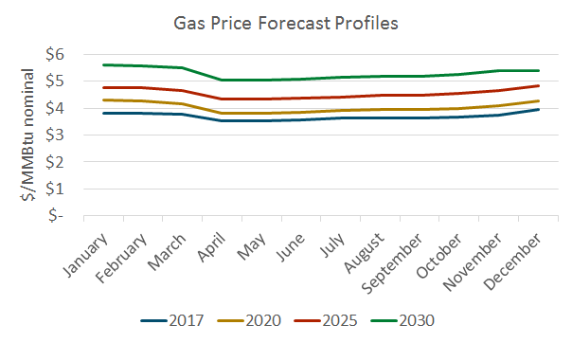

For the avoided costs used to evaluate natural gas EE reductions, the following costs are added to the commodity cost.

* compression (0.39%),
* losses and unaccounted for (1.37%),
* marginal transmission and delivery costs (varies by utility),
* NOX and CO2 ($5.82/lb and $15.37/short ton in 2012. Both escalate annually)

Of these additional cost items, only the CO2 $/short ton value has been updated. The cost of CO2 is discussed in more detail in the electricity avoided cost section of this memo.

The natural gas forecasts discussed above are for burner tip, so the incremental cost of transportation for core gas customers is added to the commodity cost for the gas avoided cost for retail customers. The incremental transportation costs are updated for the current IOU gas tariffs (Effective May 2016), and assumed to escalate at 2% per year.

The marginal cost of gas distribution capacity has not been revised in this update.

# Overview of Electricity Avoided Cost Components

This section provides a brief overview of the electricity avoided cost components and their contribution to the total electricity avoided costs. This is followed by detailed discussions of the updates for each component in the subsequent sections.

The avoided cost used for electricity energy efficiency evaluation is calculated as the sum of six components shown in Table 1.

Table . Components of electricity avoided cost

|  |  |
| --- | --- |
| Component | Description |
| Generation Energy | Estimate of hourly wholesale value of energy |
| Generation Capacity | The costs of building new generation capacity to meet system peak loads |
| Ancillary Services | The marginal costs of providing system operations and reserves for electricity grid reliability |
| T&D Capacity | The costs of expanding transmission and distribution capacity to meet peak loads |
| Environment | The cost of carbon dioxide emissions associated with the marginal generating resource |
| Avoided RPS | The reduced purchases of renewable generation at above-market prices required to meet an RPS standard due to a reduction in retail loads |

Each of these avoided costs is must be determined for every hour of the year. The hourly granularity is obtained by shaping forecasts of the average value of each component with historical day-ahead and real-time energy prices and actual system loads reported by CAISO’s MRTU system for 2015; Table 2 summarizes the methodology applied to each component to develop this level of granularity.

Table . Summary of methodology for electricity avoided cost component forecasts

|  |  |  |
| --- | --- | --- |
| Component | Basis of Annual Forecast | Basis of Hourly Shape |
| Generation Energy | Forward market prices and the $/kWh fixed and variable operating costs of a CCGT. | Historical hourly day-ahead market price shapes from MRTU OASIS |
| Generation Capacity | Residual capacity value a new simple-cycle combustion turbine | RECAP model that generates outage probabilities by month/hour, and allocates the probabilities within each month/hour based on 2015 weather. |
| Ancillary Services | Percentage of Generation Energy value | Directly linked with energy shape |
| T&D Capacity | Marginal transmission and distribution costs from utility ratemaking filings. | Hourly temperature data. Unchanged in this update. |
| Environment | CO2 cost forecast from 2015 IEPR mid-demand forecast, escalated at inflation beyond 2030. | Directly linked with energy shape with bounds on the maximum and minimum hourly value |
| Avoided RPS | Cost of a marginal renewable resource less the energy market and capacity value associated with that resource | Flat across all hours. |

Figure 3, below, shows a three-day snapshot of the avoided costs, broken out by component, in Climate Zone 4. As shown, the cost of providing an additional unit of electricity is significantly higher in the summer afternoons than in the very early morning hours. This chart also shows the relative magnitude of different components in this region in the summer for these days. The highest peaks of total cost shown in Figure 3 of over $10,000/MWh are driven primarily by the allocation of generation and T&D capacity to the peak hours (because of high demand in those hours), but also by higher energy market prices during the middle of the day.

Figure . Three-day snapshot of energy values in CZ4 in 2017



Figure 4 shows average monthly value of electricity reductions, revealing the seasonal characteristics of the avoided costs. The energy component dips in the spring, reflecting low energy prices due to increased hydro supplies and imports from the Northwest; and peaks in the summer months when demand for electricity is highest. The value of capacity—both generation and T&D—is concentrated in the summer months and results in significantly more value on average in these months.

Figure : Average monthly avoided cost in CZ13 in 2017

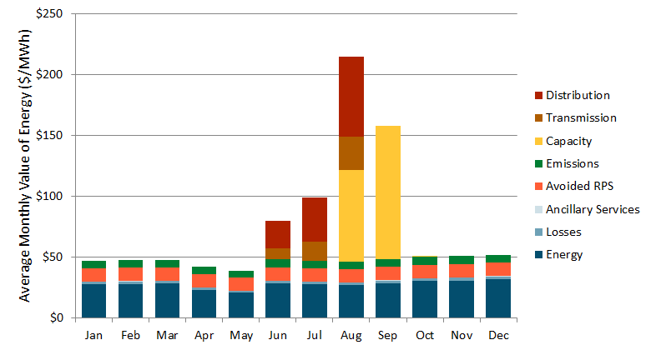

Figure 5 shows the components of value for the highest value hours in sorted order of cost. This chart shows the relative contribution to the highest hours of the year by component. Note that most of the high cost hours occur in approximately the top 200 to 400 hours—this is because most of the value associated with capacity is concentrated in a limited number of hours. While the timing and magnitude of these high costs differ by climate zone, the concentration of value in the high load hours is a characteristic of the avoided costs in all of California.

Figure . Price duration curve showing top 1,000 hours for CZ13 in 2017

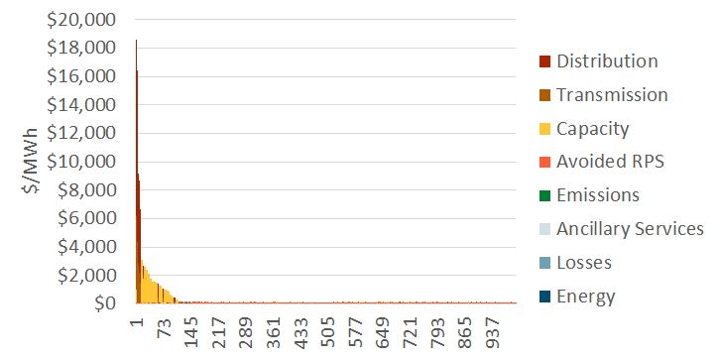

# Avoided Cost Methodology

## Generation Energy

The treatment of generation avoided costs receives a methodology update in 2016 to reflect the recognition of carbon prices in the electricity market price forecasts. The prior 2011 update was able to rely upon market price data that pre-dated the Cap-and-Trade Program. The updated methodology starts with market prices that include CO2 costs, and decomposes the market price into an energy component and a CO2 component based on the 2015 IEPR CO2 prices and the inferred market heat rates. A full discussion of the updates for generation energy is listed below.

* Capital costs, financing and performance information for a CT are taken from the March 2015 CEC *Estimated Cost of New Renewable and Fossil Generation in California* report[3]. Cost and performance is based on a merchant advanced turbine plant. For consistency with the CCGT calculations, the installed cost of the turbine is used as an input, rather than the instant cost, and the adjustments to convert instant costs to installed costs have been removed from the avoided cost calculator. In addition, the CT pro-forma calculations previously added in the cost of sales taxes. As those costs are already captured in the CEC report’s installed costs, that adjustment has also been removed.
* The CT pro-forma model included a Domestic Manufacturing Tax Credit. That had minimal effect and has been removed for consistency with the CCGT pro-forma model.
* Capital Costs, financing and performance data for a CCGT are also updated using the March 2015 CEC *Estimated Cost of New Renewable and Fossil Generation in California* report. A merchant two unit combined cycle unit without duct firing is used. As with the prior avoided cost update, a book life of 20 years is assumed for both the CT and CCGT.
* The day ahead market price shapes are updated using SNL day-ahead hourly price data for 2015. The real-time market price shapes are calculated using MRTU 5-min price data.

### Determination of energy market values

The updated avoided energy costs are developed using a method similar to what was used for CSI. The average energy cost in the near term is based on the OTC Global Holdings Forwards on-peak and off-peak market price forecasts for NP-15 and SP-15, averaged to calculate the system value (available through 2023 for the update in 2016). For the period after the available forward market prices, the method interpolates between the last available futures market price and the long-run energy market price. The long-run energy market price is used for the resource balance and all subsequent years. Note that if the resource balance year is set to present, the long-run energy market price is used in all years.

The annual long-run energy market price is set so that the CCGT’s energy market revenues plus the capacity market payment equal the fixed and variable costs plus carbon costs of the CCGT (i.e.: the CCGT is made whole).

The long-run energy market price begins with the implied heat rate in the last year that electricity market forwards are available. This implied heat rate is then held constant for all subsequent years. The market energy price is calculated using the corresponding gas and carbon prices in each subsequent year along with variable O&M costs. This market energy price is then increased or decreased with an energy market calibration factor so that the CCGT is made whole. The energy market calibration factor is applied to both 1) the real-time market prices used to determine CT energy revenues and the value of capacity, and 2) the day-ahead energy market used to determine CCGT energy revenues. This creates a feedback effect between the energy and capacity avoided costs. The feedback effect is illustrated with the following example.

*Assume that the CCGT would collect more revenue through the capacity and energy markets than is needed to cover its costs. The methodology decreases the calibration factor to decrease the day-ahead energy market prices and market revenues to make the CCGT whole. To keep the real-time and day-ahead markets in sync, the methodology also would decrease the real-time energy market prices by the calibration factor. The decrease in real-time energy market prices would result in lower net revenues for a CT, and therefore raise the value of capacity (as higher capacity payment revenue is needed to incent a new CT to build). When we re-examine the CCGT, the raised value of capacity results in the CCGT collecting excess revenues, so the calibration factor needs to be decreased more, and the process repeats[4].*

Figure : Annual Average Energy Avoided Costs

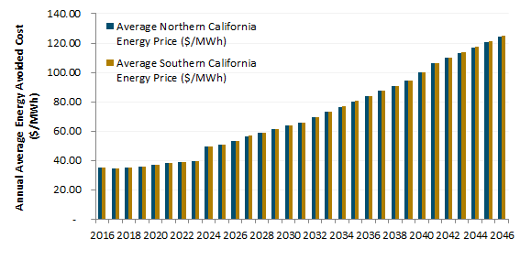

### Hourly Shaping of Energy Costs

The annual energy avoided costs are converted to hourly values by multiplying the annual value by 8760 hourly market shapes. The hourly shape is derived from day-ahead LMPs at load-aggregation points in northern and southern California obtained from the SNL's day-ahead hourly pricing data for 2015. In order to account for the effects of historical volatility in the spot market for natural gas, the hourly market prices are adjusted by the average daily gas price in California, the cost of carbon, and variable O&M. The resulting hourly market heat rate curve is integrated into the avoided cost calculator, where, in combination with a monthly natural gas price forecast, forecasted carbon prices, and variable O&M, it yields an hourly shape for wholesale market energy prices in California.

Total energy avoided costs are shown in Figure 7. The avoided costs are shown in descending order for all 8760 hours of the year.

Figure : Hourly Energy Avoided Costs for 2017

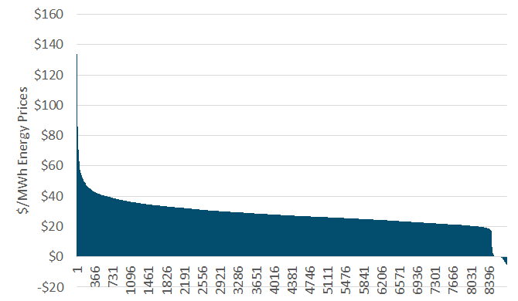

## Generation Capacity

The long-run generation capacity cost is the levelized capital cost of a new simple cycle CT unit less the margin that the CT could earn from the energy and ancillary service markets. The calculation has been updated to include carbon costs in both the bid prices for the CT and the market prices for energy. Minor adjustments have also been made to the calculation of the CT levelized cost of capacity to be consistent with the method used for the CCGT calculations.

Previously, the generation capacity cost has transitioned from a near-term capacity cost based on Resource Adequacy costs, to the long-run capacity cost based on the Resource Balance Year. The May 3, 2016 Proposed Decision of Commissioner Florio in R.14-10-003 has essentially set the Resource Balance Year to zero, which would result in the use of the long-run capacity cost for all years. That is the approach taken in the results presented herein. While not used for the avoided cost calculations, a resource balance year consistent with past practices is shown below for informational purposes.

### Generation resource balance year

E3 has calculated a resource balance year using the 2015 IEPR mid load forecast and the latest available resources forecast from the RPS Calculator version 6.2. In keeping with past precedent, incremental energy efficiency and uncommitted demand response are not included in the calculation of the resource balance year since outputs of the avoided cost calculator are in turn used to evaluate the cost-effectiveness of these resources. A 13,396 MW import assumption is also used for consistency with the RPS Calculator. In the chart below, 'load' can be interpreted as peak load plus planning reserve margin requirements. The 'resources' are calculated as the sum of the ELCC of all available resources in each year, plus imports, minus demand response.

Figure . Evaluation of resource balance year

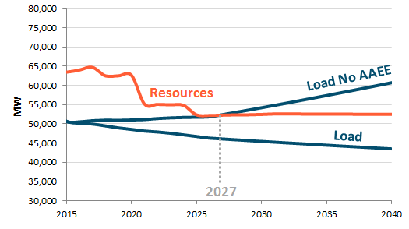

### CT dispatch

To determine the long-run value of capacity, the avoided cost model performs an hourly dispatch of a new CT to determine energy market net revenues. The CT’s net margin is calculated assuming that the unit dispatches at full capacity in each hour that the real-time price exceeds its operating cost (the sum of fuel costs, variable O&M, and carbon costs). In each hour that it operates, the unit earns the difference between the market price and its operating costs, plus an additional 2.74% of the market price for ancillary services[5]. In each hour where the market prices are below the operating cost, the unit is assumed to shut down. The dispatch uses the real-time market shape (not the day-ahead market shape), and adjusts for changes in natural gas prices, temperature performance degradation using average monthly 9am – 10pm temperatures (see the section *Temperature effect on unit performance* on page 21), and a market calibration factor[6].

The market revenues earned in the energy and AS markets are subtracted from the fixed and variable costs (including carbon costs) of operating a CT to determine the residual capacity cost. The residual capacity cost is the additional revenue that a new CT would require in order to fully cover its fixed costs and return on investment, and is used as a proxy for the long-term avoided cost of generation capacity. The generation capacity cost calculations are performed using both Northern California and Southern California market prices and weather information. The cost of a new CT, however, is the same for both Northern and Southern California. Consistent with the DR methodology implemented in the prior avoided cost model, the final generation capacity cost for each year is the average of the results for Northern and Southern California (50% Northern and 50% Southern).

In addition to data updates, the CT dispatch incorporates two methodology changes

1. Carbon and variable O&M costs are included in the CT dispatch bids and market revenue calculations because such carbon costs are recovered through the energy market.
2. The hourly real-time market shape is based on the 2015 shape and held constant for all future years. This shape is not adjusted in the same way as the day-ahead price shape due to the disconnect between the two as well as large increase in volatility seen in the real-time price shape.

Figure 9: Statewide Generation Capacity Value before Temperature and Loss Adjustments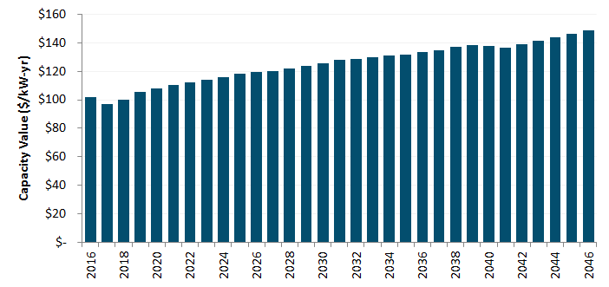

### Temperature effect on unit performance

The capacity value as $ per kW of degraded capacity, rather than $ per kW of nameplate capacity to account for the effects of temperature. This re-expression increases the $/kW capacity value by about 8%. The use of the degraded capacity was introduced in the DR proceeding to more precisely model to operation of a combustion turbine at different ambient temperature conditions throughout the year. Use of degraded, rather than nameplate, capacity value results an increase in the capacity value because combustion turbines perform at lower efficiencies when the ambient temperature is high.

The CT’s rated heat rate and nameplate capacity characterize the unit’s performance at ISO conditions,[7] but the unit’s actual performance deviates substantially from these ratings throughout the year. In California, deviations from rated performance are due primarily to hourly variations in temperature. Figure 10 shows the relationship between temperature and performance for a GE LM6000 SPRINT gas turbine, a reasonable proxy for current CT technology.

Figure . Temperature-performance curve for a GE LM6000 SPRINT combustion turbine.



The effect of temperature on performance is incorporated into the calculation of the CT residual; several performance corrections are considered:

* In the calculation of the CT’s dispatch, the heat rate is assumed to vary on a monthly basis. In each month, E3 calculates an average day-time temperature based on hourly temperature data throughout the state and uses this value to adjust the heat rate—and thereby the operating cost—within that month.
* Plant output is also assumed to vary on a monthly basis; the same average day-time temperature is used to determine the correct adjustment. This adjustment affects the revenue collected by the plant in the real-time market. For instance, if the plant’s output is 90% of nameplate capacity in a given month, its net revenues will equal 90% of what it would have received had it been able to operate at nameplate capacity.
* The resulting capacity residual is originally calculated as the value per nameplate kilowatt—however, during the peak periods during which a CT is necessary for resource adequacy, high temperatures will result in a significant capacity deration. Consequently, the value of capacity is increased by approximately 10% to reflect the plant’s reduced output during the top 250 load hours of the year as shown in Figure 11.

The forecast annual generation capacity values are shown below.

Figure . Adjustment of capacity value to account for temperature derating during periods of peak load (losses still excluded)

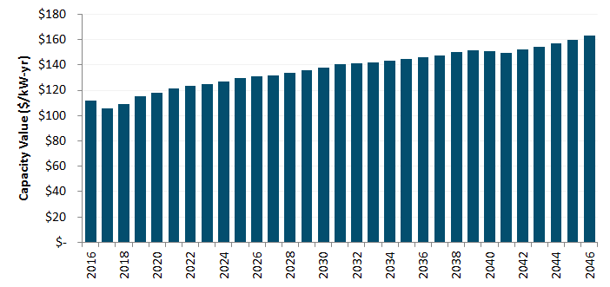

### Planning reserve margin and losses

The capacity value is increased to account for both the Planning Reserve Margin (PRM) and losses. Resource Adequacy rules set capacity procurement targets for Load Serving Entities based on 1.15% of their forecasted load.[8] The must also account for losses in delivering electricity from the generator to the customer, based on peak loss factors for each utility. The capacity value is therefore increased by the PRM and the applicable loss factors for each utility. Note that peak loss factors are used for generation and T&D capacity while TOU loss factors are used for energy.

### Hourly allocation of capacity value

The capacity values ($/kW-yr), after adjusting for temperature, losses, and planning reserve margin, are then allocated to the hours of the year with highest system capacity need using the E3 RECAP model. Using 63 years of historical load and generation data, the model determines the expected unserved energy (EUE) for each month/hour/day-type time period in the year. As renewable penetrations increase, EUE shifts from the afternoon to evenings as well as to a relatively more weekends. A snapshot of these hourly EUE values in 2020 is shown below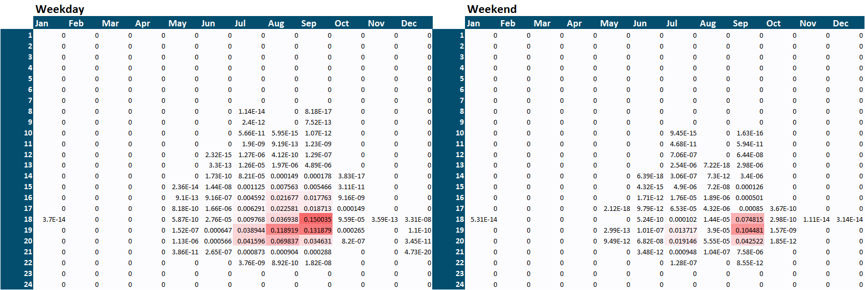

These month/hour/day-type EUE values are then allocated to days of the year using the 2015 daily temperature record for consistency with energy prices. A load-weighted daily maximum statewide temperature is calculated and all hours in days where this value exceeds 90 degrees F receive the corresponding month/hour/day-type EUE value from RECAP. The resulting 8760 hourly capacity allocators are shown below.

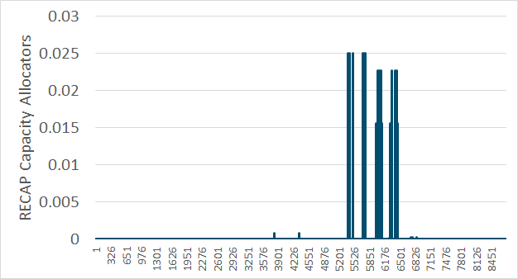

A downloadable version of RECAP can be found online.[9] The results shown above use this version of the model along with load and renewable generation forecasts consistent with the LTPP “Default – AAEE Sensitivity” scenario. E3 also plans to update renewable generation profiles and the dispatchable generator stack list before the final version of the model is released.

## Ancillary Services (AS)

Besides reducing the cost of wholesale purchases, reductions in demand at the meter result in additional value from the associated reduction in required procurement of ancillary services. The CAISO MRTU markets include four types of ancillary services: regulation up and down, spinning reserves, and non-spinning reserves. The procurement of regulation services is generally independent of load; consequently, behind-the-meter load reductions and distributed generation exports will not affect their procurement. However, both spinning and non-spinning reserves are directly linked to load—in accordance with WECC reliability standards, the California ISO must maintain an operating reserve equal to 5% of load served by hydro generators and 7% of load served by thermal generators.

As a result, load reductions do result in a reduction in the procurement of reserves; the value of this reduced procurement is included as a value stream in the Avoided Cost Calculator. It is assumed that the value of avoided reserves procurement scales with the value of energy in each hour throughout the year. According to the CAISO’s 2015 Annual Report on Market Issues and Performance[10], ancillary service costs in 2015 averaged 0.7% of the wholesale energy costs. E3 uses this percentage to assess the value of avoided A/S procurement in each hour.

## T&D Capacity

The avoided electricity avoided costs include the value of reducing the need for transmission and distribution capacity expansion. Of the six avoided cost components, T&D costs are unique in that both the value and hourly allocation are location specific. Avoided T&D costs are determined separately for each utility. The avoided T&D costs have been updated by climate zone for PG&E, and at the system level for SCE and SDG&E territories based on utility ratemaking proceedings. The T&D avoided costs escalate by 2% per year in nominal terms.

Table : Updated T&D Capacity Costs for SCE and SDG&E



SCE 2015 General Rate Case: http://docs.cpuc.ca.gov/PublishedDocs/Efile/G000/M155/K034/155034804.PDF, p.6

SDG&E 2015 General Rate Case: https://www.sdge.com/sites/default/files/regulatory/Saxe%20Clean%20w_Attachments.pdf Attachment A

Table 4: Updated T&D Capacity Costs for PG&E



*\* Secondary values converted from $/FLT to $/PCAF using ratios of FLT demand to PCAF demand in each Division*

*PG&E 2014 General Rate Case: http://docs.cpuc.ca.gov/PublishedDocs/Efile/G000/M099/K767/99767963.PDF pg A2-A3*

The value of deferring distribution investments is highly dependent the type and size of the equipment deferred and the rate of load growth, both of which vary significantly by location. Furthermore, some distribution costs are driven by distance or number of customers rather than load and are therefore not avoided with reduced energy consumption. However, expediency and data limitations preclude analysis at a feeder by feeder level for a statewide analysis of avoided costs. A more detailed examination of distribution avoided costs is currently underway for the IOUs as part of the Distribution Resource Plan proceeding (R.14-08-013). The costs taken from utility rate case filings are used as a reasonable proxy for the long-run marginal cost T&D investment that is avoided over time with the addition of distributed energy resources.

The value of deferring transmission and distribution investments is adjusted for losses during the peak period using the factors shown in Table 54 and Table 65. These factors are lower than the energy and generation capacity loss factors because they represent losses from secondary meter to only the distribution or transmission facilities.

Table 5. Losses factors for SCE and SDG&E transmission and distribution capacity.

|  |  |  |
| --- | --- | --- |
|  | SCE | SDG&E |
| Distribution | 1.022 | 1.043 |
| Transmission | 1.054 | 1.071 |

Table 6: Losses factors for PG&E transmission and distribution capacity.

|  |  |  |
| --- | --- | --- |
|  | Transmission | Distribution |
| CENTRAL COAST | 1.053 | 1.019 |
| DE ANZA | 1.050 | 1.019 |
| DIABLO | 1.045 | 1.020 |
| EAST BAY | 1.042 | 1.020 |
| FRESNO | 1.076 | 1.020 |
| KERN | 1.065 | 1.023 |
| LOS PADRES | 1.060 | 1.019 |
| MISSION | 1.047 | 1.019 |
| NORTH BAY | 1.053 | 1.019 |
| NORTH COAST | 1.060 | 1.019 |
| NORTH VALLEY | 1.073 | 1.021 |
| PENINSULA | 1.050 | 1.019 |
| SACRAMENTO | 1.052 | 1.019 |
| SAN FRANCISCO | 1.045 | 1.020 |
| SAN JOSE | 1.052 | 1.018 |
| SIERRA | 1.054 | 1.020 |
| STOCKTON | 1.066 | 1.019 |
| YOSEMITE | 1.067 | 1.019 |

### Hourly allocation of T&D capacity cost

The method for allocating T&D capacity costs to hours has been updated to better reflect the pattern and timing of peak demand on the distribution system. The prior temperature-based proxy has been replaced by a more sophisticated regression-based estimate of distribution hourly loads[11]. The regression models are based on actual utility hourly distribution demands and the corresponding temperature in the distribution area. Using dummy variables, lag terms, and cross product terms, the regression models are able to simulate the distribution loads with about 90% accuracy (adjusted r-square)[12]. To forecast the impact of local solar PV on the distribution loads, the analysis also subtracts off a forecast level of hourly PV generation from the distribution load to produce an adjusted distribution load shape. The PV generation shape is based on the local area solar insolation, and the magnitude of the PV generation is based on the incremental statewide 2015 IEPR Mid-Demand forecast of solar penetration. 50 percent of the statewide incremental PV is assumed to be installed equally on a per-capital basis across the state, and the remaining 50% is assumed to be installed in proportion to the 2013 per-capita installations.

Once the adjusted distribution loads are simulated using 2015 weather data for each climate zone and the PV penetrations, we allocate the T&D capacity value in each climate zone to the hours of the year during which the system is most likely to be constrained and require upgrades—the hours of highest local load. The allocation factors are derived using the peak capacity allocation factors method, with the additional constraint that the peak period contain between 20 and 500 hours for the year.

PCAF[a,h] = (Load[a,h] – Threshold[a]) / Sum of all positive (Load[a,h] – Threshold[a])

Where

a is the climate zone area,

h is hour of the year,

Load is the net distribution load, and

Threshold is the area maximum demand less one standard deviation, or the closest value that satisfies the constraint of between 20 and 250 hours with loads above the threshold.

Figure 12 shows a summary of the updated T&D allocation factors for Climate Zone 3 (Oakland) in 2020. The blue line shows the total allocation weight for each hour of the day (in Pacific Standard Time) and the red dashed line shows the same information for the replaced allocation factors. The gray bars show the total allocation weight by month (top axis, and right axis). The chart title also indicates that the allocation factors are based on behind-the-meter PV proving an additional 6.4% of the electricity needs in the climate zone since 2010. The PV values are incremental to 2010 because that is the year of the utility load data used as the basis for the simulated area loads. The additional PV output is subtracted from the simulated loads to estimate the adjusted net loads for the climate zone.

Figure 12. Updated T&D Allocation Factors for CZ3 in 2020

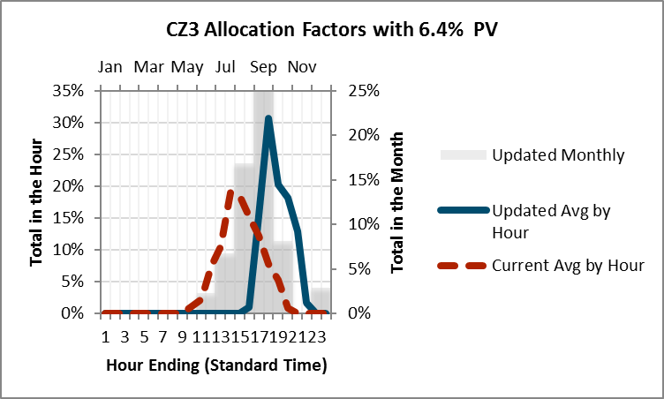

Figure 13 shows the same information for climate zone 3 in 2030. In 2030 the behind-the-meter PV is modeled as providing 20.2% of the electricity needs in the climate zone. This higher PV output results in less need for summer afternoon peak capacity. This shits the allocation factors to later in the day/evening, as well as shifting more weight to the non-summer months. Summary charts for all 16 climate zones are presented in the Appendix.

Figure 13. Updated T&D Allocation Factors for CZ3 in 2030

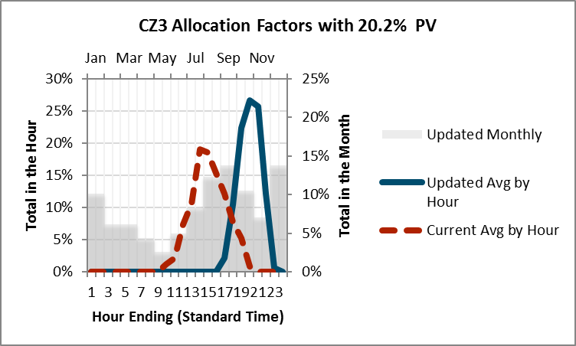

The 2020 allocation factors are used for all years up to and including 2020, and the 2030 shapes are used for 2030 and all subsequent years. A simple linear interpolation is applied to the interim years.

Table : Percentage of Electricity Demand Met by Behind-the-Meter PV

|  |  |  |
| --- | --- | --- |
| Climate Zone | 2020 | 2030 |
| CZ1 | 6.2% | 18.1% |
| CZ2 | 10.1% | 24.2% |
| CZ3 | 6.4% | 20.2% |
| CZ4 | 9.5% | 24.3% |
| CZ5 | 4.9% | 13.3% |
| CZ6 | 2.5% | 10.3% |
| CZ7 | 3.4% | 11.5% |
| CZ8 | 2.3% | 10.1% |
| CZ9 | 2.2% | 10.2% |
| CZ10 | 3.5% | 11.8% |
| CZ11 | 9.2% | 23.6% |
| CZ12 | 5.1% | 13.0% |
| CZ13 | 8.5% | 22.9% |
| CZ14 | 5.0% | 14.0% |
| CZ15 | 3.2% | 11.7% |
| CZ16 | 7.0% | 21.5% |

## Monetized Carbon (Cap & Trade)

The monetized cost of carbon represents the monetary cost that the utility must pay to purchase or generate fossil energy. While this value is currently embedded in energy prices in the CAISO market, we separate this value for avoided cost purposes. This component has been updated to use the 2015 IEPR Mid-Case forecast values. The IEPR forecast extends to 2030. For later years, the forecast is extrapolated using a linear trend of the values in the final five years of the IEPR forecast. This update replaces a forecast developed by Synapse Consulting in 2008. Figure 14 shows the updated CO2 price forecasts.

Figure 14. The CO2 price series embedded in the avoided cost values

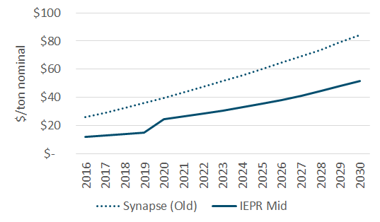

In the prior avoided cost model, the avoided cost of energy was forecast without the cost of CO2. The CO2 costs were therefore an additional cost item and added to the total avoided cost forecast. In this update, the cost of CO2 is included in the cost of energy because of the established Cap and Trade market, and the total avoided cost of energy is decomposed into an energy avoided cost and an environmental cost[13].

The marginal rate of carbon emissions is calculated using a slight modification to the prior avoided cost model method. Assuming that natural gas is the marginal fuel in all hours, the hourly emissions rate of the marginal generator is calculated based on the day-ahead market price curve (with the assumption that the price curve also includes the cost of CO2).

HeatRate[h] = (MP[h] – VOM) / (GasPrice + EF * CO2Cost)

Where

MP is the hourly market price of energy (including cap and trade costs)

VOM is the variable O&M cost for a natural gas plant

GasPrice is the cost of natural gas delivered to an electric generator

CO2Cost is the $/ton cost of CO2

EF is the emission factor for tons of CO2 per MMBTU of natural gas

The link between higher market prices and higher emissions rates is intuitive: higher market prices enable lower-efficiency generators to operate, resulting in increased rates of emissions at the margin. Of course, this relationship holds for a reasonable range of prices but breaks down when prices are extremely high or low. For this reason, the avoided cost methodology bounds the maximum and minimum emissions rates based on the range of heat rates of gas turbine technologies. The maximum and minimum emissions rates are bounded by a range of heat rates for proxy natural gas plants shown in Table 7; the hourly emissions rates derived from this process are shown in Figure 14. The emission rate bounds are unchanged from the prior avoided cost model.

Table 8. Bounds on electric sector carbon emissions.

|  |  |  |
| --- | --- | --- |
|  | Proxy Low Efficiency Plant | Proxy High Efficiency Plant |
| Heat Rate (Btu/kWh) | 12,500 | 6,900 |
| Emissions Rate (tons/MWh) | 0.731 | 0.404 |

Additionally, if the implied heat rate is calculated to be at or below zero, it is then assumed that the system is in a period of overgeneration and therefore the marginal emission factor is correspondingly zero as well. A snapshot comparison between implied market heat rate and implied emission rate is shown below.

Figure 15. Hourly emissions rates derived from market prices (hourly values shown in descending order)

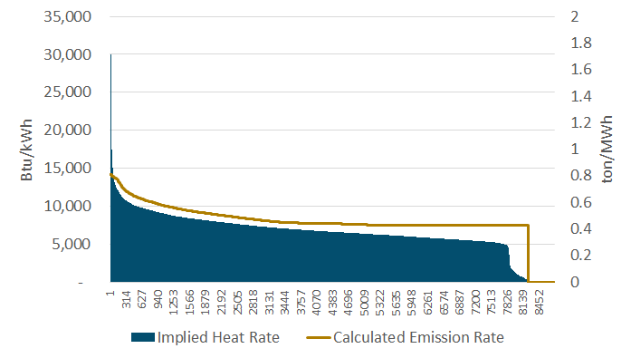

## Avoided RPS Cost

The Avoided RPS Cost component has been updated with pricing information from the RSP Calculator version 6.2, and the current California RPS policy goals for the IOUs (33% in 2020 and 50% by 2030).

This component reflects the fact that as energy usage declines, the amount of utility renewable purchases required to meet the RPS goals also declines. Since the cost of renewable energy is higher than the forecasted cost of wholesale energy and capacity market purchases, energy reductions provide some value above the wholesale energy and capacity markets.

The Avoided RPS Cost component is a function of the Renewable Premium, the incremental cost of the marginal renewable resource above the cost of conventional generation. The marginal renewable resource is based upon an energy-only (not fully deliverable) tracking solar PV resource. Energy-only means that the resource is attributed no incremental transmission costs and consequently, no capacity value is netted off of the total renewable cost. The Renewable Premium is calculated by subtracting the market energy value (including CO2) associated with this resource from its levelized cost of energy as shown in Figure 15. The Avoided RPS Cost is calculated directly from the Renewable Premium by multiplying by the RPS goal for that year. For example, in 2021 the Avoided RPS Cost is equal to the Renewable premium * 33%, as, for each 1 kWh of avoided retail sales, 0.33 kWh of renewable purchases are avoided. The Avoided RPS Cost increases linearly between a 2016 compliance obligation of 25% and a 2030 compliance obligation of 50%.

Figure 16. Evaluation of the Renewable Premium

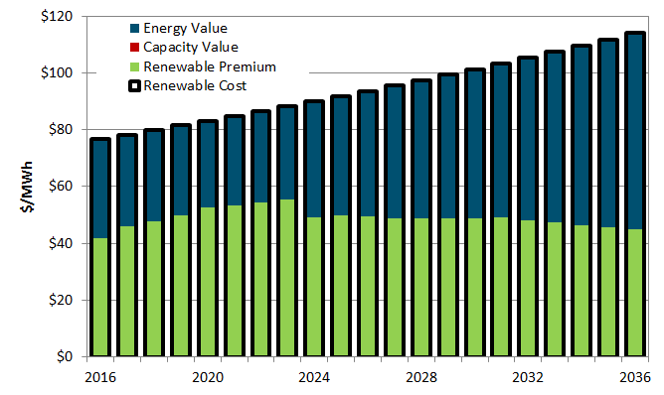

Figure 17: Annual Avoided RPS Cost

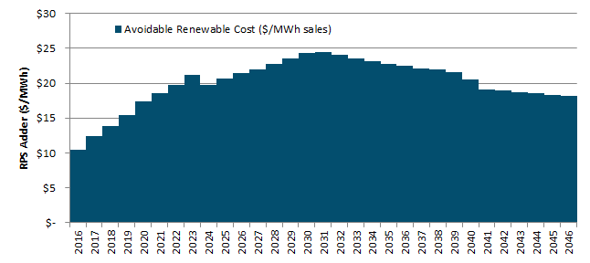

## Greenhouse Gas Adder

This version of the avoided cost calculator incorporates a greenhouse gas (GHG) adder. This GHG adder is meant to represent any additional societal or external cost of GHGs that are not captured in the existing monetized carbon emission component of avoided costs. In the 2017 update, a set of interim GHG adder values were adopted which are based on the California Air Resources Board Cap-and-Trade Allowance Price Containment Reserve (APCR) and are replicated in Table 9.

Table : Interim GHG Adder Values: Based on CARB Cap-and-Trade APCR Prices



From these values, the existing cap-and-trade price forecast ($/tonne) that is already used to calculate the emissions component in the avoided cost is subtracted, leaving only the incremental portion of the GHG adder.

The next step to calculating the GHG adder is determining the GHG emission rate in each hour. To determine this, we first calculate an implied heat rate (Btu/kWh) in each hour. The implied heat rate is calculated by subtracting the cap-and-trade emission value and variable operations and maintenance (O&M) expense of a CCGT from the energy price in each hour and then dividing by the natural gas price. This implied heat rate is then multiplied by the GHG intensity of natural gas (tonne/Btu) which yields an intermediate emission factor in tonne/kWh. This intermediate value is then multiplied by (1 minus the RPS%) to yield a final emission factor. This RPS adjustment is necessary because California’s RPS policy is based on retail sales of electricity. When a distributed resource saves a kWh of electricity, the utility consequently procures 0.5 kWh less renewable energy (under a 50% RPS). This RPS that the utility no longer procures would have offset GHG emissions itself, and so the resulting net GHG impact must be adjusted by (1 minus the RPS%).

Finally, the incremental portion of the GHG adder price ($/tonne) is multiplied by the RPS adjusted emission rate (tonne/kWh) to yield a final GHG adder value ($/kWh) in each hour. A sample result of this final GHG adder value is shown below for an average day.

Figure : GHG Adder Values for Average Day: CZ 13, 2017 start year, 15 yr levelization period



Components Not Included

Several components suggested by stakeholders in various proceedings are not currently included in the calculation of avoided costs. Non-energy Benefits (NEBs), by their nature, are difficult – if not impossible – to quantify. Work has been done to quantify some of these benefits for low income energy efficiency programs.[14] NEBs are not, however, currently included in the avoided cost methodology. The CPUC has authorized studies and pilot programs regarding embedded energy in water. To date a comprehensive framework for calculating embedded energy in water savings or water avoided costs in energy on a statewide basis has not yet been developed.[15] Avoided costs of current or future Ancillary Services associated with renewable integration or overgeneration are also not included. The need for flexible resources to provide services such as load following or ramping capability are driven primarily by the variation in, rather than the absolute level of, loads and generation. Finally the impacts of power factor and reactive loads are not currently included in the avoided cost methodology. An EM&V study for the CPUC Operational Energy Efficiency Program for water pumping produced by E3 found that the value of reduced reactive loads (kVAR) and associated line loss reductions ranged from 5 to 12 percent of the $/kWh avoided cost savings.[16] However the savings associated with improved power factor and reduced reactive load depend to a large extent on the type and location of loads on the feeder. As with embedded energy in water, a generalized framework for a statewide analysis has not yet been performed.

# Comparison of the Updated EE Avoided Costs to Current EE Avoided Costs

Shown in this section are the total annual average avoided costs for DEER measures by climate zone. The avoided costs for generation (Gen) and transmission and distribution (T&D) are plotted separately. The current EE annual average avoided costs for each DEER measure are shown as stacked lines. Gen includes energy, emissions, ancillary services, Avoided RPS cost, and generation losses. T&D shows T&D capacity and losses. The annual average avoided costs using the updated avoided costs are plotted as stacked column charts.

For each utility a plot of the DEER measure shape avoided costs are shown for 2020, followed by 2030.

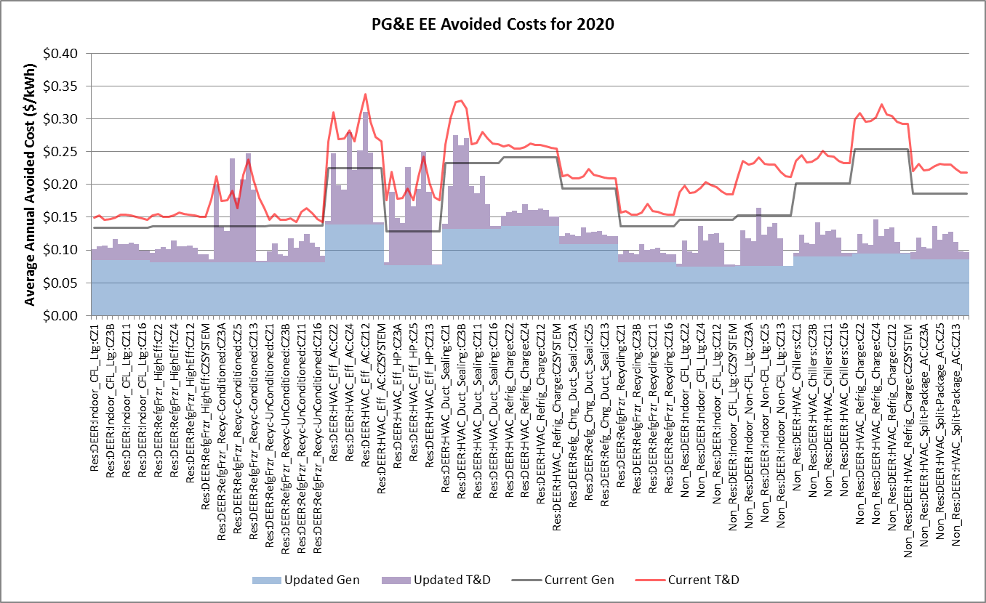

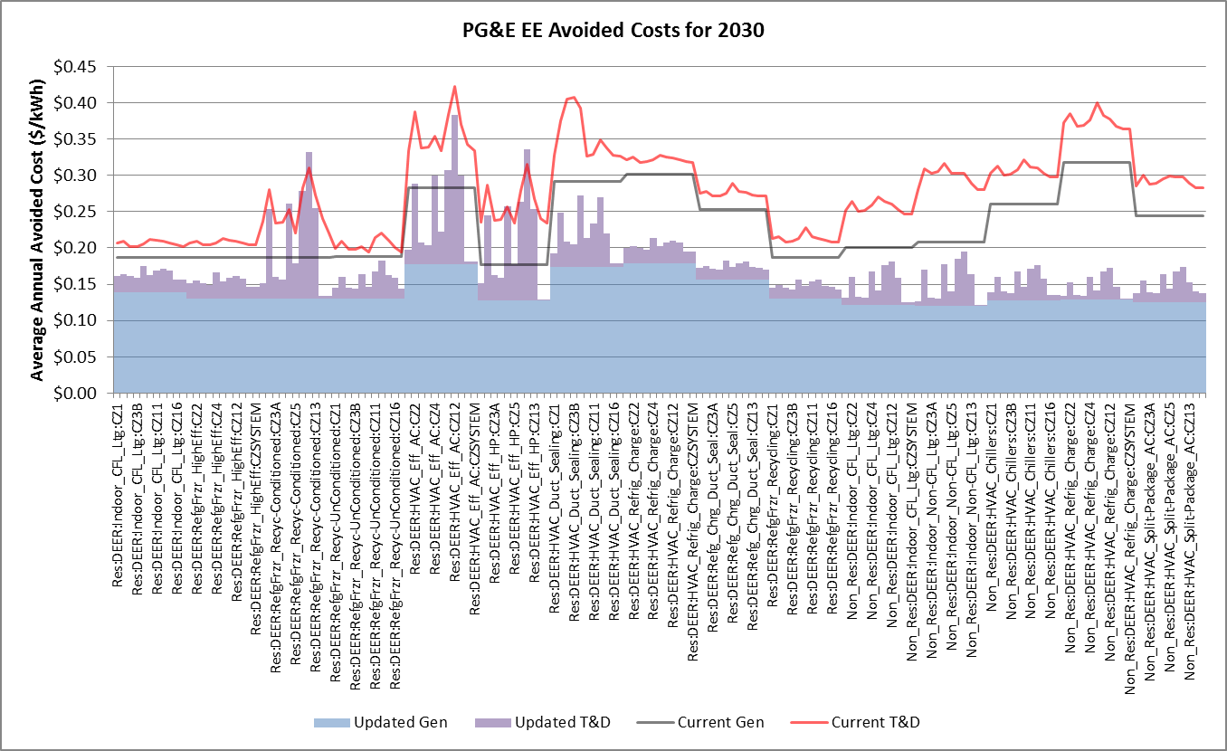

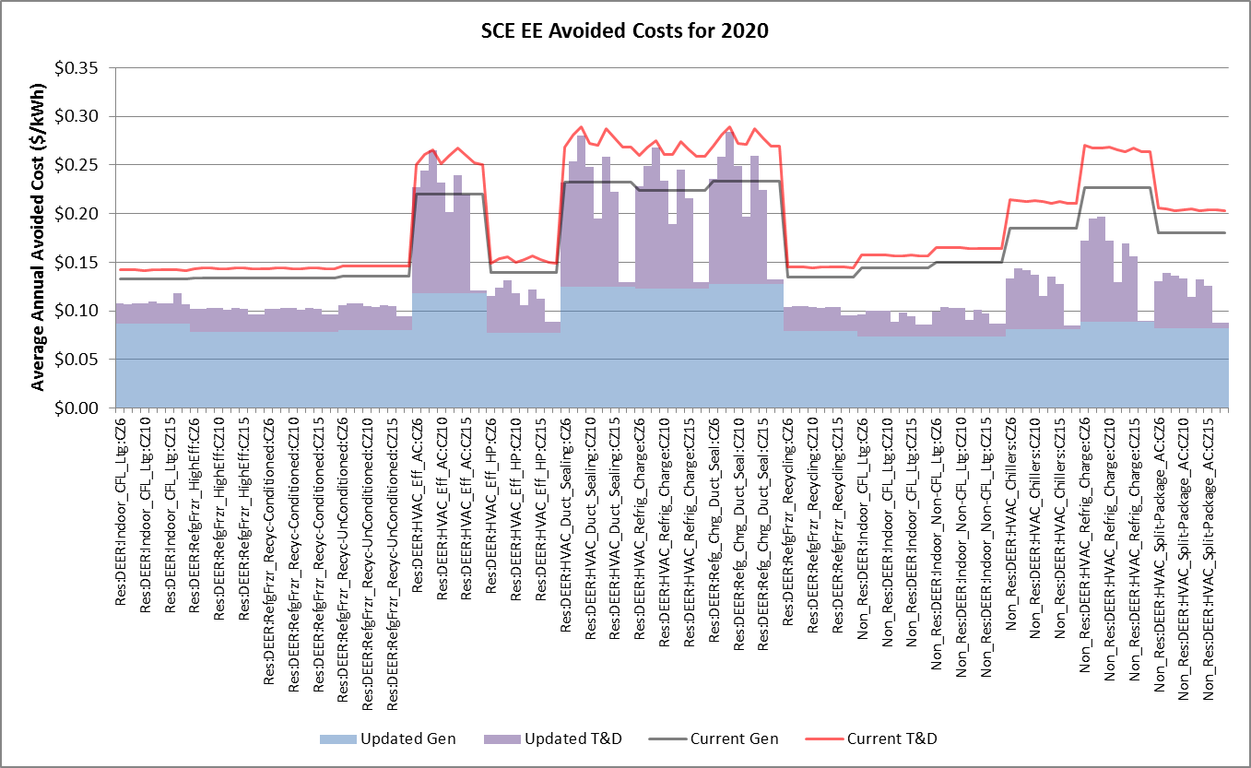

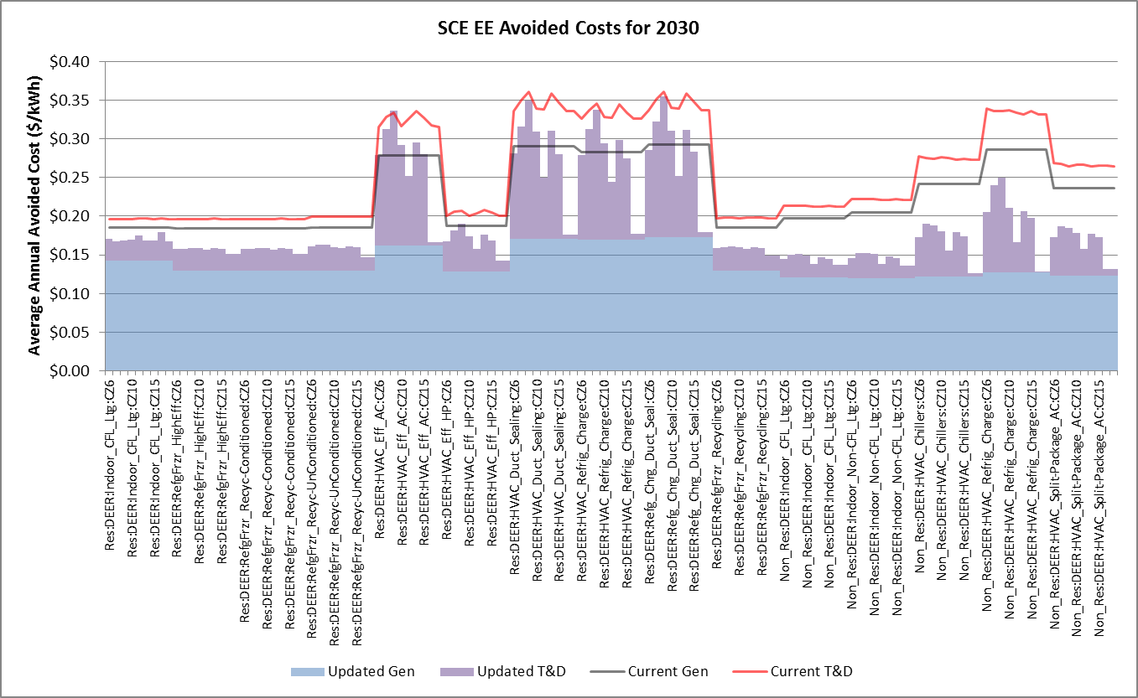

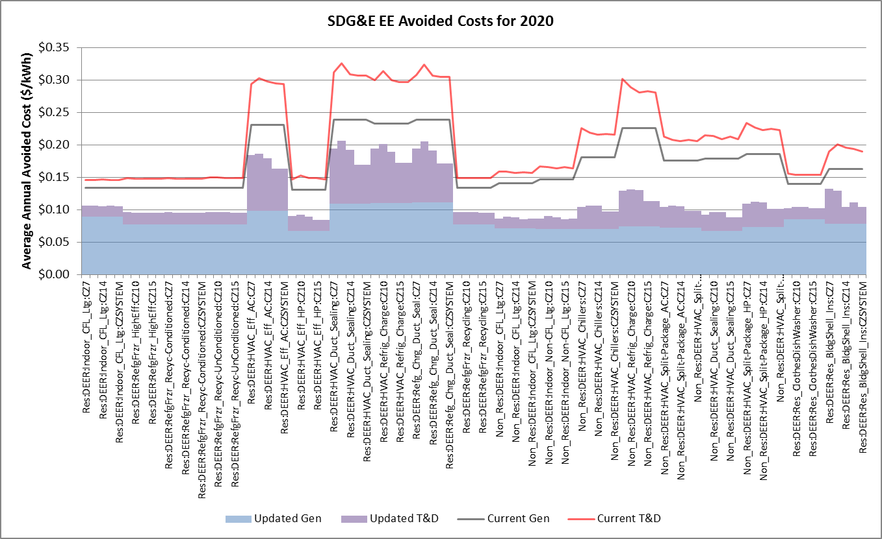

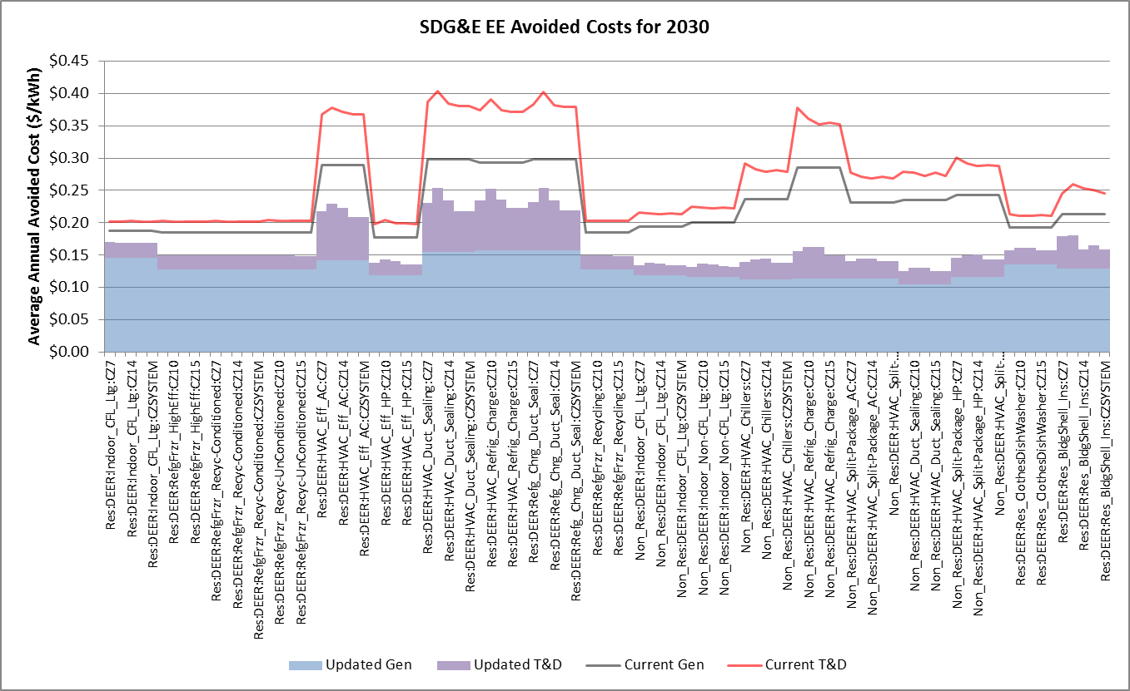

# Appendix: Key Data Sources and Specific Methodology

This section provides further discussion of data sources and methods used in the calculation of the hourly avoided costs.

## Power plant cost assumptions

The cost and performance assumptions for the new simple cycle plants are based on the 100 MW simple cycle turbine included in the California Energy Commission’s Cost of Generation report.

Table 10. Power plant cost and performance assumptions for Combustion Turbine (Advanced)

|  |  |  |
| --- | --- | --- |
| Item | Value | Source Notes |
| Operating Data |  |  |
| Heat rate (Btu/kWh) | 9,880 | Table 49 |
| Lifetime (yrs) | 20 | Table 14 |
| Scheduled Outage Factor | 3.18% | Appendix B-5 |
| Forced Outage Rate | 4.13% | Appendix B-5 |
| Costs |  |  |
| Installed Cost ($/kW) | $1,069 | Table 3, Merchant, 2013 nominal |
| Fixed O&M ($/kW-yr) | $23.87 | Table 57, 2011 Nominal |
| Variable O&M ($/MWh) | $0.00 | Table 58, 2011 Nominal |
| Plant Cost Escalation Rate | 2.5% | pg 138; 2% inflation + 0.5% real escalation |
| Cost Basis Year | 2013 | Table 3, Merchant |
| Financing |  |  |
| Debt % | 67% | Table 1 |
| Debt Cost | 4.52% | Table 1 |
| Equity Cost | 13.25% | Table 1 |

*Source: CEC 2015 Cost of New Renewable and Fossil Generation in California, http://www.energy.ca.gov/2014publications/CEC-200-2014-003/index.htmlTable 8.*

Table : Power plant cost and performance assumptions for Combined Cycle Combustion Turbine (No Duct Firing)

|  |  |  |
| --- | --- | --- |
| Item | Value | Source Note |
| Operating Data |  |  |
| Heat rate (Btu/kWh) | 7,250 | Table 49 |
| Lifetime (yrs) | 20 | Table 14 |
| Costs |  |  |
| Installed Cost ($/kW) | $1,088 | Table 3, Merchant, 2013 nominal |
| Fixed O&M ($/kW-yr) | $32.69 | Table 57, 2011 Nominal |
| Variable O&M ($/MWh) | $0.58 | Table 58, 2011 Nominal |
| Plant Cost Escalation Rate | 2.5% | pg 138; 2% inflation + 0.5% real escalation |
| Cost Basis Year | 2013 | Table 3, Merchant |
| Financing |  |  |
| Debt % | 67% | Table 1 |
| Debt Cost | 4.52% | Table 1 |
| Equity Cost | 13.25% | Table 1 |
|  |  |  |
| Cost Basis for O&M Costs | 2011 | Table 57 and Table 58 |

*Source: CEC 2015 Cost of New Renewable and Fossil Generation in California, http://www.energy.ca.gov/2014publications/CEC-200-2014-003/index.htmlTable 8.*

## Generation Loss Factors

The updated avoided costs incorporate loss factors from the DR proceeding. The capacity loss factors are applied to the capacity avoided costs to reflect the fact that dispatched generation capacity is greater than metered loads because of losses. The adjustments assume that the metered load is at the secondary voltage level. The loss factors are representative of average peak losses, not incremental losses.

Table 12: Generation capacity loss factors

|  |  |  |  |
| --- | --- | --- | --- |
|  | PG&E | SCE | SDG&E |
| Generation to meter | 1.109 | 1.084 | 1.081 |

The energy loss factors are applied to the electricity energy costs to reflect energy losses down to the customer secondary meter. The loss factors vary by utility time of user period, and represent average losses in each time period.

Energy Generated[h] = Metered Load[h] * Energy Loss Factor[TOU]

Cost of Energy Losses = Energy Cost[h] * Metered Load [h] * (Energy Loss Factor[TOU] – 1)

where h = hour, TOU = TOU period corresponding to hour h.

Table 13. Marginal energy loss factors by time-of-use period and utility.

|  |  |  |  |
| --- | --- | --- | --- |
| Time Period | PG&E | SCE | SDG&E |
| Summer Peak | 1.109 | 1.084 | 1.081 |
| Summer Shoulder | 1.073 | 1.080 | 1.077 |
| Summer Off-Peak | 1.057 | 1.073 | 1.068 |
| Winter Peak | - | - | 1.083 |
| Winter Shoulder | 1.090 | 1.077 | 1.076 |
| Winter Off-Peak | 1.061 | 1.070 | 1.068 |

## Climate Zones

In each hour, the value of electricity delivered to the grid depends on the point of delivery. The DG Cost-effectiveness Framework adopts the sixteen California climate zones defined by the Title 24 building standards in order to differentiate between the value of electricity in different regions in the California. These climate zones group together areas with similar climates, temperature profiles, and energy use patterns in order to differentiate regions in a manner that captures the effects of weather on energy use. Figure 18 is a map of the climate zones in California.

Figure 19. California Climate Zones

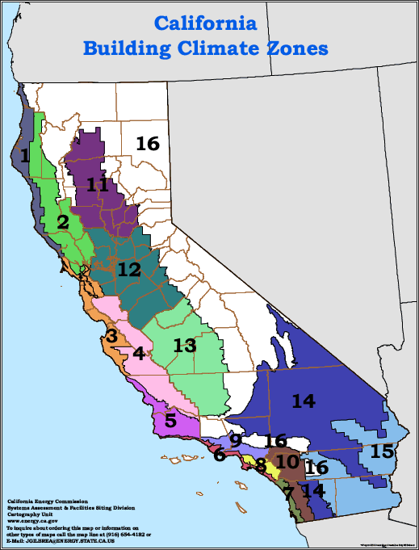

Each climate zone has a single representative city, which is specified by the California Energy Commission. These cities are listed in Table 1211. Hourly avoided costs are calculated for each climate zone.

Table 14. Representative cities and utilities for the California climate zones.

|  |  |  |
| --- | --- | --- |
| Climate Zone | Utility Territory | Representative City |
| CEC Zone 1 | PG&E | Arcata |
| CEC Zone 2 | PG&E | Santa Rosa |
| CEC Zone 3 | PG&E | Oakland |
| CEC Zone 4 | PG&E | Sunnyvale |
| CEC Zone 5 | PG&E/SCE | Santa Maria |
| CEC Zone 6 | SCE | Los Angeles |
| CEC Zone 7 | SDG&E | San Diego |
| CEC Zone 8 | SCE | El Toro |
| CEC Zone 9 | SCE | Pasadena |
| CEC Zone 10 | SCE/SDG&E | Riverside |
| CEC Zone 11 | PG&E | Red Bluff |
| CEC Zone 12 | PG&E | Sacramento |
| CEC Zone 13 | PG&E | Fresno |
| CEC Zone 14 | SCE/SDG&E | China Lake |
| CEC Zone 15 | SCE/SDG&E | El Centro |
| CEC Zone 16 | PG&E/SCE | Mount Shasta |

## T&D Allocation Factors

For a description of the charts, refer to the discussion of Figure 12 and Figure 13 on page 30.

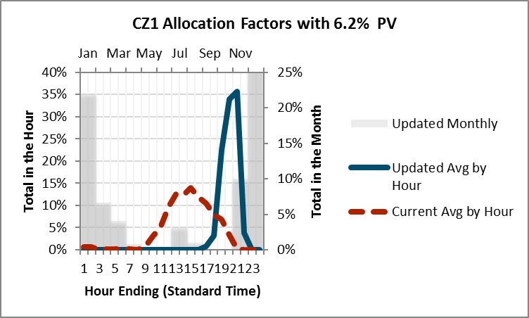

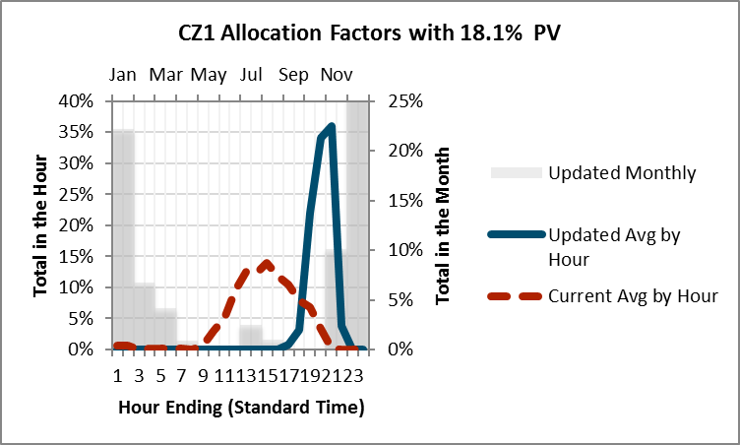

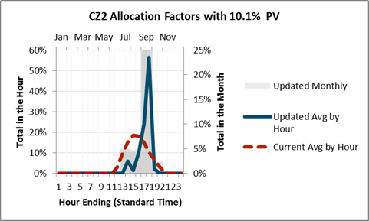

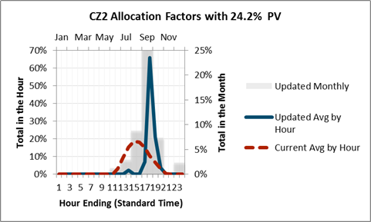

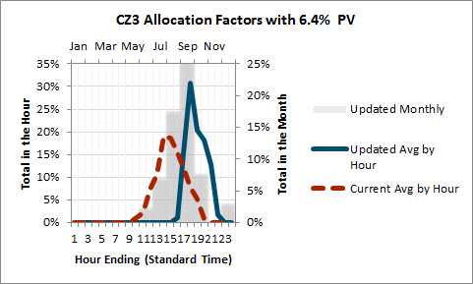

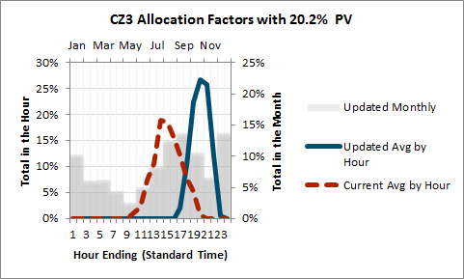

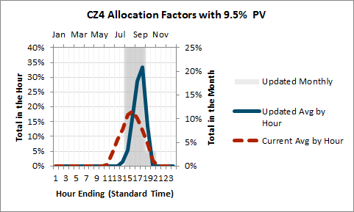

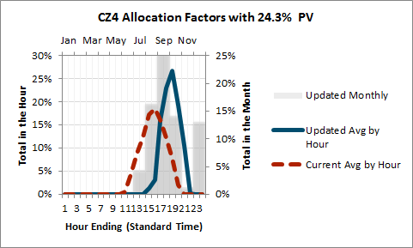

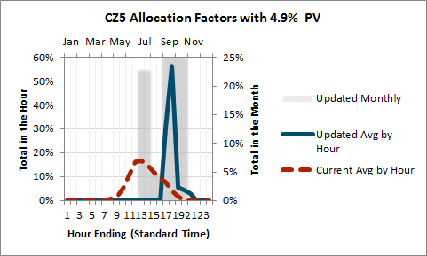

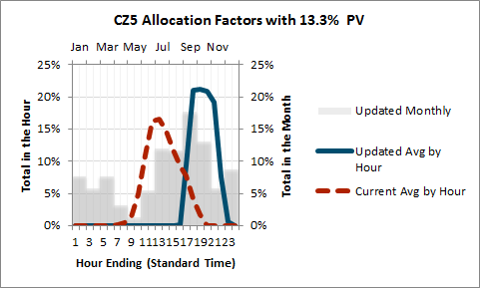

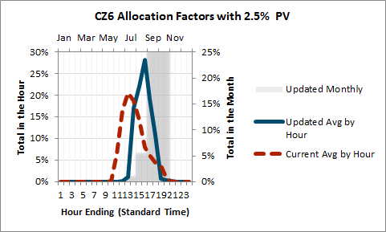

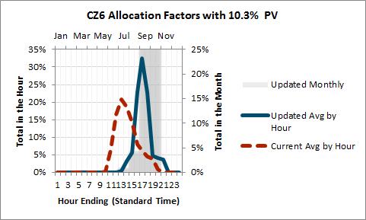

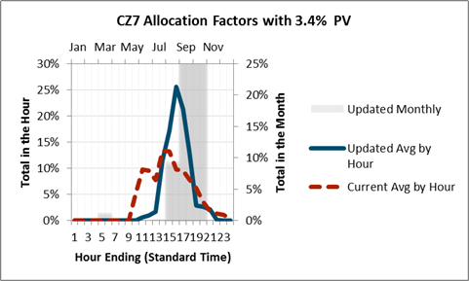

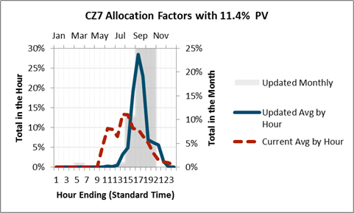

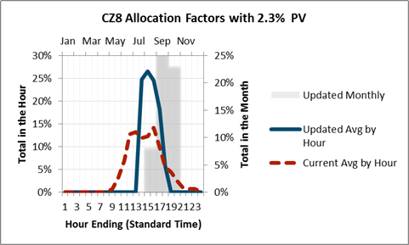

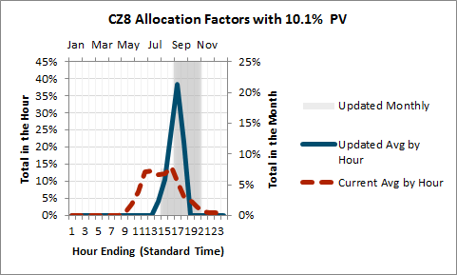

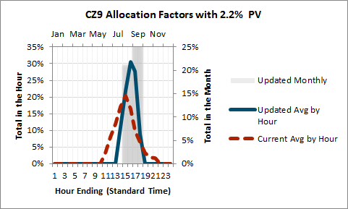

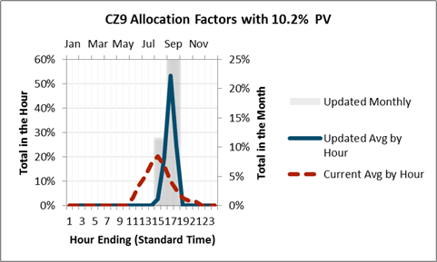

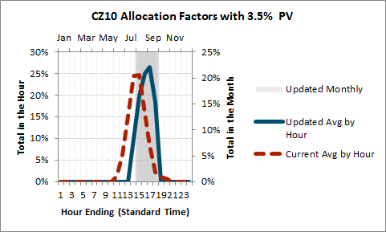

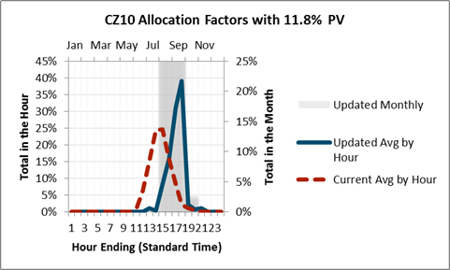

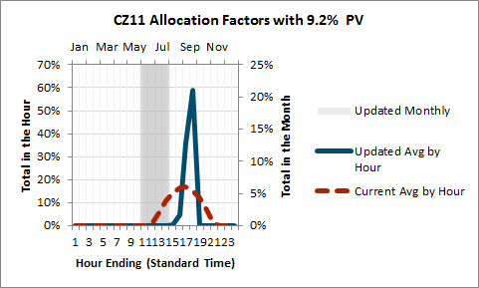

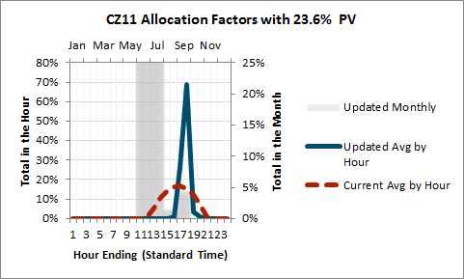

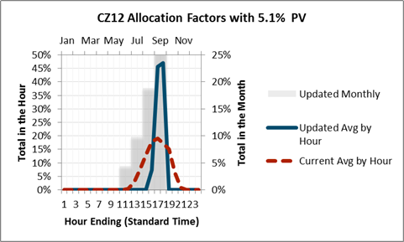

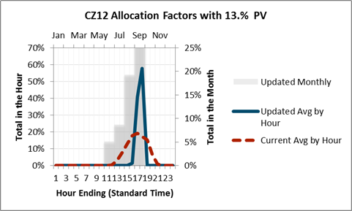

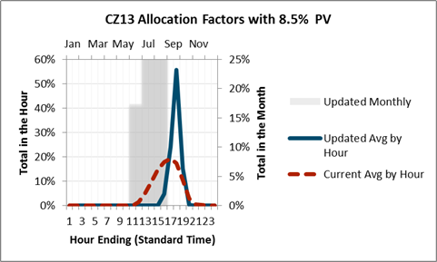

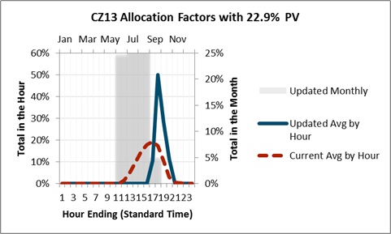

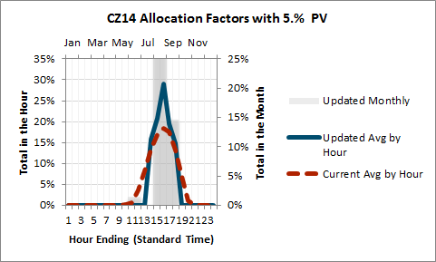

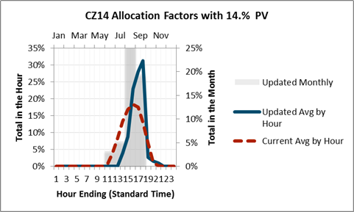

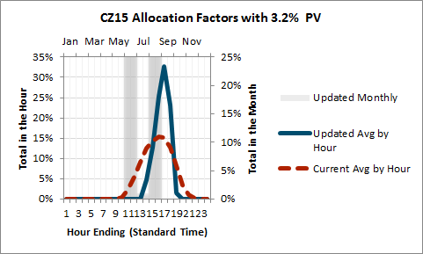

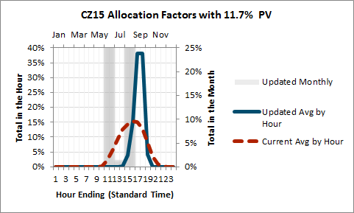

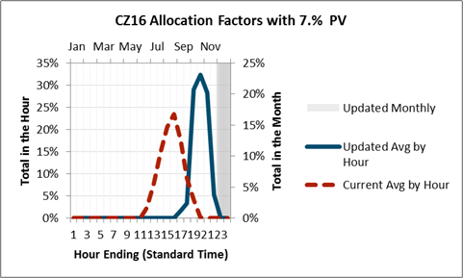

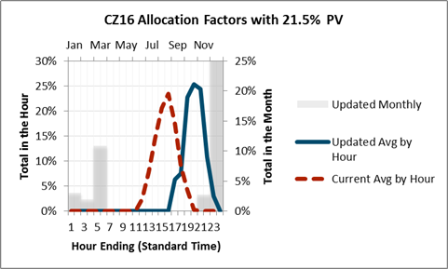

Table : Distribution Demand Regression Variables



Table : Distribution Demand Regression Model Fit



*Note that not all climate zones have readily available load data. In those cases, the regression equations from comparable climate zones were applied.*

## Distribution Load Simulation Regression Model *Specifications*

CZ2

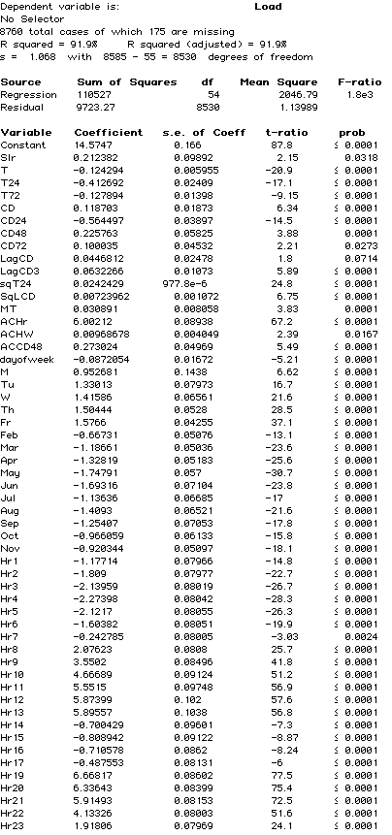

CZ3

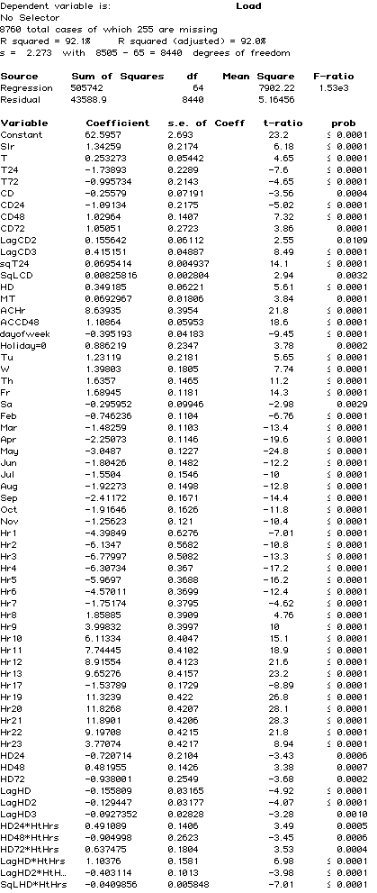

CZ4

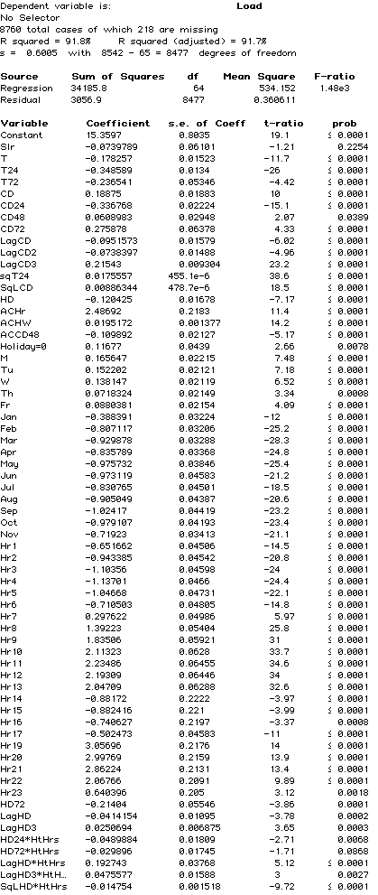

CZ6

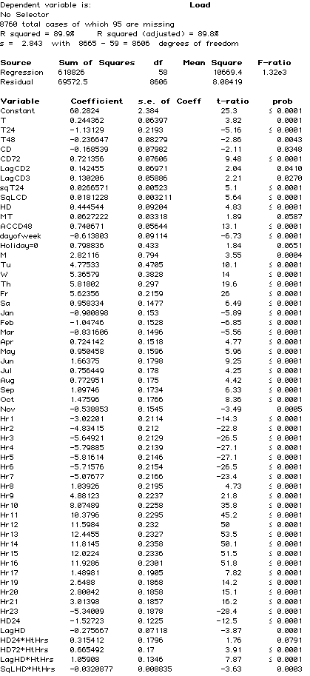

CZ7

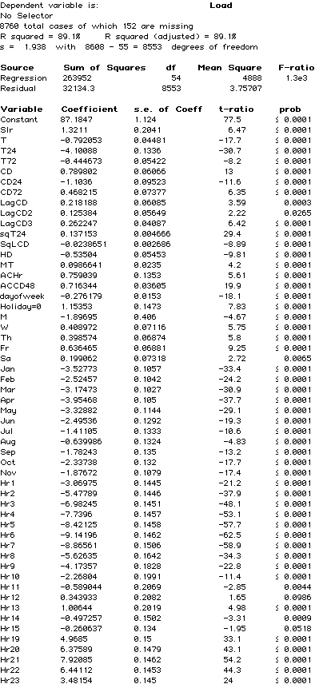

CZ8

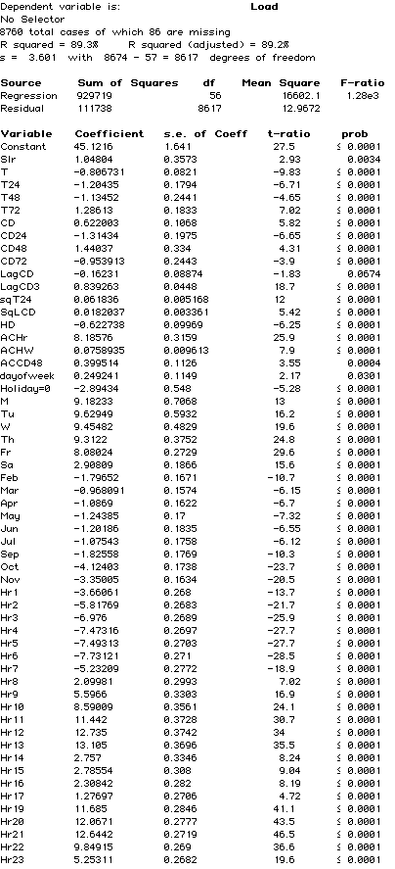

CZ9

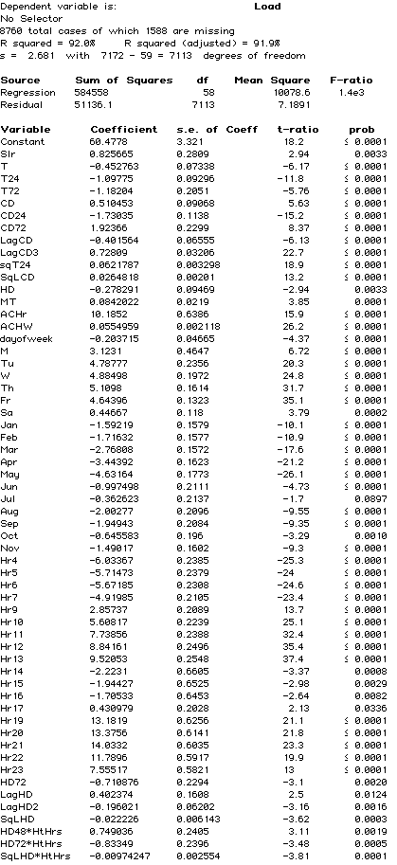

CZ 10

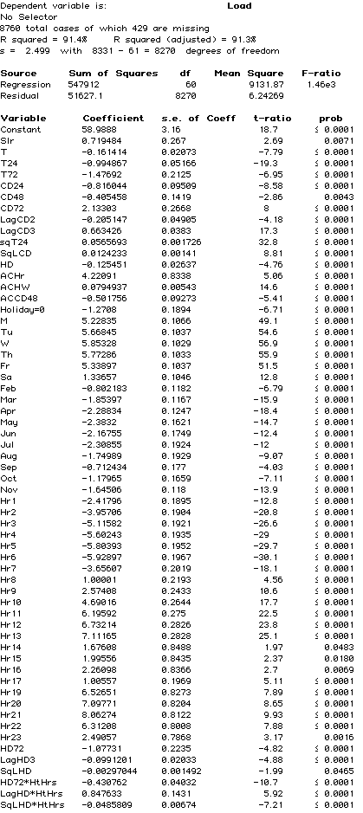

CZ12

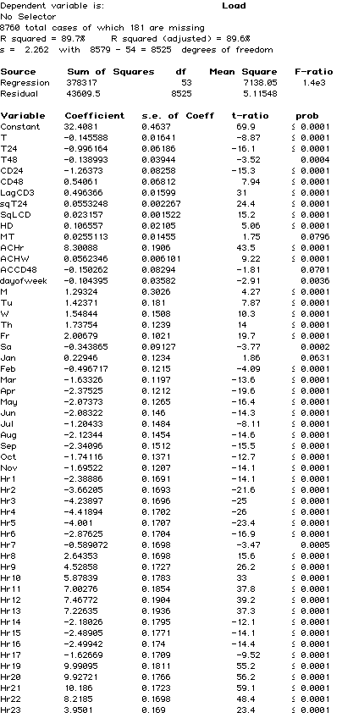

CZ13

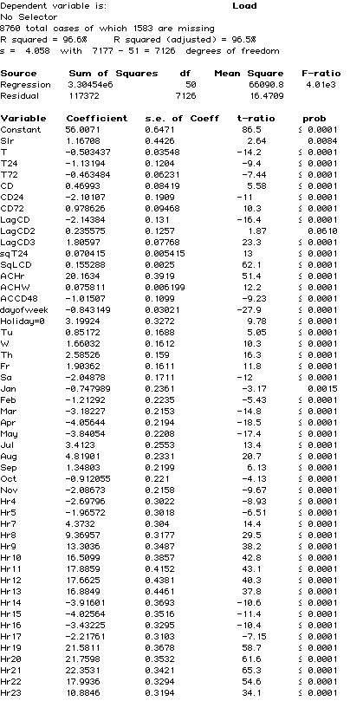

CZ 14



CZ15

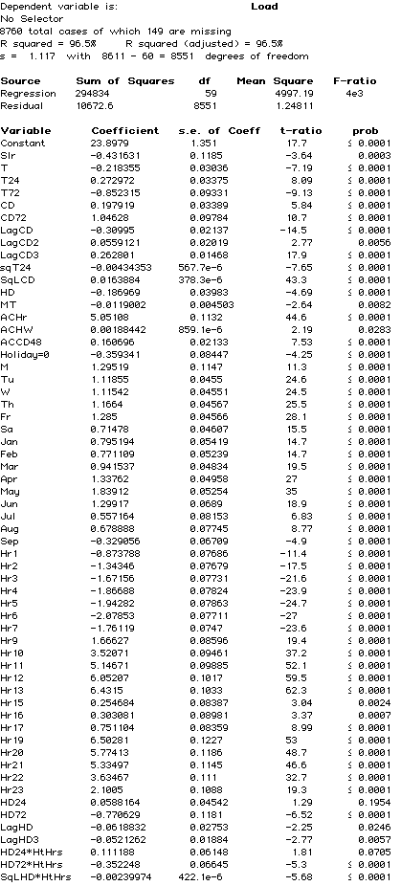

CZ16

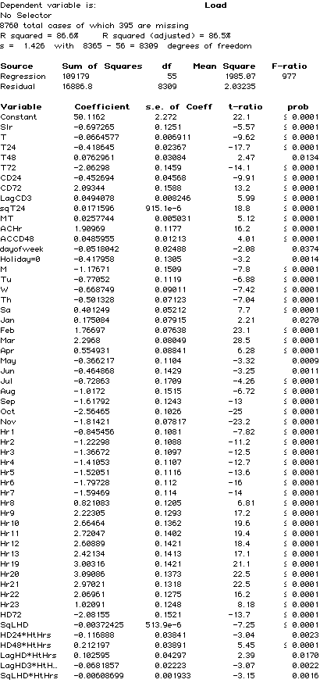

# User Quick Guide ACC 2016 v1

## Purpose

The Avoided Cost Calculator (ACC) is a Microsoft Excel-based tool to calculate electricity avoided costs by hour and component. The ACC shows levelized hourly costs by component for one year on the **Dashboard** tab. The ACC can also generate the 31 year matrices of hourly costs by climate zone that are used for energy efficiency evaluation in California. These 31 year matrices are generated via VBA code and executed via the **Export Annual Avoided Costs – ALL CZ** and **Export Gen 7 Env for EE** buttosn on the **Dashboard** tab.

## Using the Model

The **Dashboard** tab will be the primary tab used by most users of the ACC. The tab provides user controls for the electricity avoided cost components to include in the output. The tab also allows the user to control which year, or which stream of years is represented in the tab output. The **Dashboard** tab also provides figures that summarize the results of the user's avoided cost choices, as well as the associated levelized hourly avoided costs by component (located just below the user controls).

Table : Summary of Controls

|  |  |
| --- | --- |
| Control | Note |
| Utility | PG&E, SCE, or SDG&E |
| Climate Zone | The ACC produces avoided costs that are specific to climate zones. The climate zones correspond to those used by the California Energy Commission for the Title-24 Building Energy Standards. Climate zone 3 has been divided into 3A (San Francisco and Peninsula) and 3B (Oakland and East Bay) because of the large historical difference in distribution capacity costs for those areas within climate zone 3. |
| Include Reserve Margin | (1 or 0) The default value of 1 should be used for avoided costs at the customer-level, that is avoided costs for demand-side actions. For generators that do not reduce customer load, this value should be set to zero. Reductions in load produce additional value compared to generation because of the planning reserve margin. Setting the value to zero removes the extra planning reserve margin generation capacity benefit from the avoided cost stream. |
| Start year | (2017 – 2047) This is the first year for reported avoided cost results. The avoided cost results will be expressed in this year's dollars. If a levelization period of one year is used, then the levelization results will be the avoided costs for this year only. Otherwise, this is the first year of the levelization stream.  Note that the ACC only contains avoided costs through 2047, so the combination of this entry and the Levelization Period should not exceed 2047. |
| Levelization Period | (1-30) The number of years to include in the levelization period. The levelization uses the real discount rate from the Inputs tab, and therefore is constant in real dollars, not nominal dollars. To convert the levelized values into annual values in nominal dollars, the levelized results should be escalated by inflation each year. |
| Electricity Components | (TRUE. FALSE) Indicates which components to include in the avoided costs displayed in the charts, and represented in the hourly results. Note that Losses are energy-related losses and are included or excluded based on the selection for Energy. Capacity-related losses are incorporated into the respective capacity avoided costs, and not reported separately. |
| Three-day shapshot Month | (1-12) The Dashboard can graph the component avoided costs for any continuous three-day period. This is the month for the first day in that period. |
| Starting Day | (1-31). This is the day of the month for the start of the three-day period. |

## Exporting Hourly Results

In addition to the levelized or single year results discussed above, the Avoided Cost Calculator can produce hourly avoided costs for 2017 through 2047. Because the amount of data associated with 31 years of hourly avoided costs, these results are output to separate Excel files, rather than added to the model itself. In addition, the results are written to the output files as the total avoided cost by year and hour, but not by avoided cost component[17]. All results are reported in $/MWh at the secondary voltage level.

The output files are written to a subfolder in the same directory as the Avoided Cost Model. The subfolder is named according the date the macro is run.

There are three macros included in the Avoided Cost Calculator. The buttons for each macro are located below Cell F20 on the Dashboard tab. Each macro is described below.

|  |  |
| --- | --- |
| Macro | Comment |
| Export Annual Avoided Costs – All CZ | Using the user-selected utility, the macro will iterate through each climate zone that applies to the utility. The macro will write the total hourly avoided costs for the components indicated by the *Electricity Component* inputs, and will include or exclude the planning reserve margin benefit base on the user input for *Incl Reserve Margin*. Note that because the macro is outputting results by year for all years, instead of levelized results, the Levelization Period and the Start year are ignored. |
| Export Annual Avoided Costs – One CZ | Same functionality as the macro above, but only outputs results for the user selected Climate Zone. |
| Export Gen & Env for EE | This is a specialized macro used to create output files used for the E3 Calculator and CET. It overrides the user selections to generate the needed transfer file for the selected utility. This should not be used by the general user of the model. |

## DR Reporting and PLS Tool Interface

Finally, the model aggregates specific outputs for input into the DR Reporting Tempate which is used to determine the cost-effectiveness of demand response.

The *DR Outputs* tab is an exact replica of the Inputs tab in the DR Reporting Template. Thus, the tab can be directly copy/pasted into the DR Reporting Template. A screenshot of this tab is shown below.

Figure : DR Outputs Tab in Avoided Cost Calculator

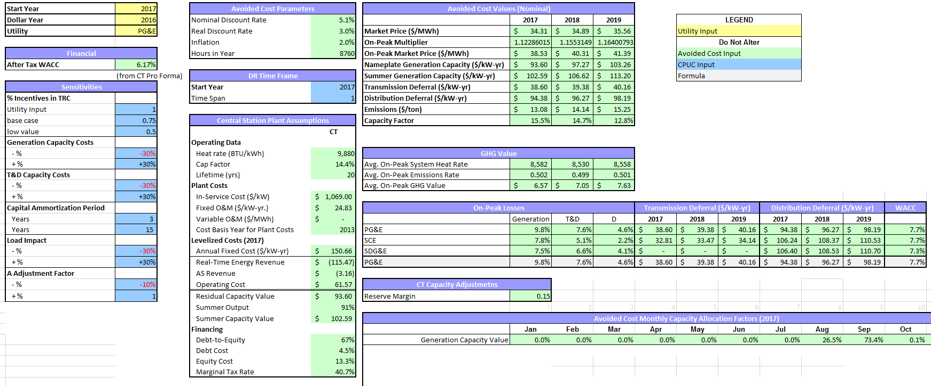

Additionally, the *PLS Outputs* tab organizes outputs of the Avoided Cost Calculator that can be copy/pasted as inputs into the *PLS Inputs* tab of the DR Reporting Template. A screenshot of this tab is shown below.

Figure : PLS Outputs tab in Avoided Cost Calculator

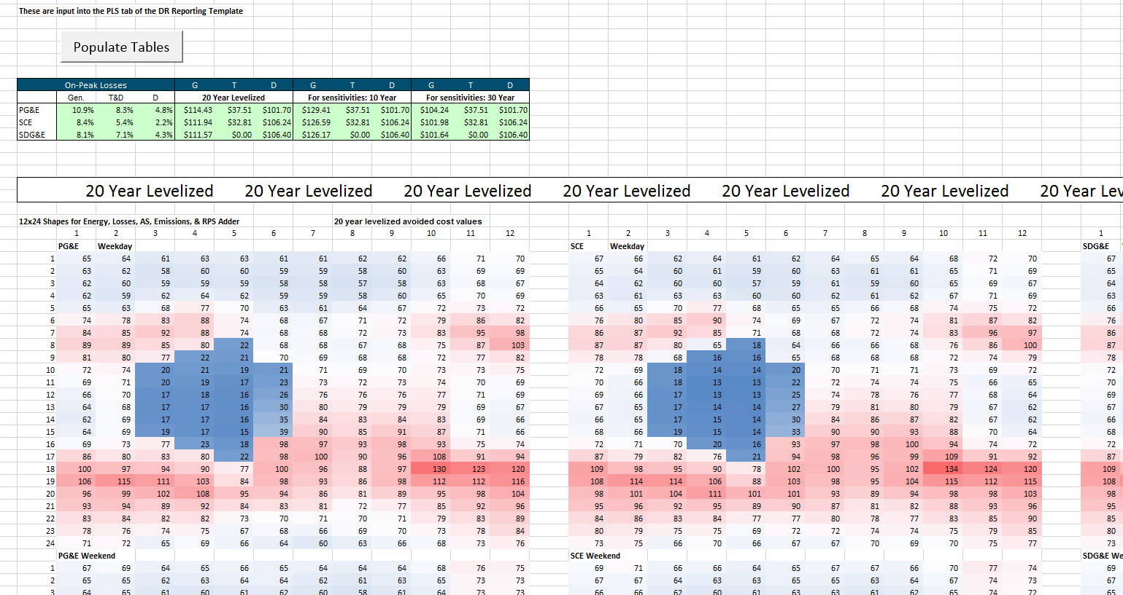

## Inputs

The data inputs for the model are on two tabs. The Hourly Data tab contains the hourly inputs for the model such as energy price shapes and capacity allocation factors. The Inputs tab contains the other inputs for the ACC, including natural gas costs, CO2 costs per ton, CT and CCGT plant costs, and T&D capacity costs.

If the user alters an input that affects energy or capacity, the calibration macro will need to be re-run. This can be done by pressing the “Calibrate Energy and Capacity Costs” button on either the Inputs or Market Dynamics tab. Note that the calibration process can be time consuming and takes about 10 minutes on a corei7 desktop PC.

## Remaining tabs

The remainder of the ACC tabs are calculation tabs, or associate with model control or tracking. These tabs are described briefly on the Cover tab for the ACC.

# Version Change Summary

Avoided Cost Model Version

Revision Date: 5/31/2016

1. **Methodology corrections and enhancements**
   1. Update T&D allocation factors to reflect recent IOU distribution loading patterns and simulate increased PV impacts on net distribution loads
   2. Replace 250 peak hour method for generation capacity allocation with unserved energy probabilities based on E3 RECAP model[18].
   3. Replace use of private long-run gas forecasts (as no longer procured by the CPUC) with IEPR and EIA escalation rate.
   4. Replace 2010 MRTU hourly energy price shapes with 2015 data and update the hourly price shapes to reflect changes in market prices expected to occur due to increased renewable generation as California continues to move toward the 50% RPS goal.
   5. Include the carbon price and variable O&M in the dispatch logic for calculating the residual net cost of generation capacity.
   6. Forecast annual energy prices that include CO2 costs (consistent with the Cap and Trade market), and decompose those prices into energy and environment components.
   7. Include adjustments to the hourly energy price profile using the CPUC RPS Calculator to account for projected increases in renewable generation. RPS Calculator implied heat rate changes by month/hour are incorporated into the price shape for 2020. Adjustments prior to 2020 are linearly interpolated, and adjustments after 2020 are held at the 2020 levels.
   8. CT levelized cost changes
      1. Change from use of instant costs to installed costs as CT plant cost input
      2. Remove manufacturer tax credit
      3. Remove short term tax effect scaling factor (as installed costs are used instead of instant costs)
2. **Simple Data Updates**
   1. Move the resource balance year (the year when the avoided costs for are based on sustaining new CT and CCGT units in the market) to 2015.
   2. Update the cost and operating characteristics of a simple cycle gas turbine (CT) and a combined cycle gas turbine (CCGT) unit with data from the CEC Estimated Cost of New Renewable and Fossil Generation in California report[19].
   3. Update the ancillary service percentage relative to energy costs to reflect 2015 markets
   4. Update the CT ancillary revenues adder with the CAISO 2015 market performance and monitoring report.
   5. Update T&D capacity costs for latest utility General Rate Case (GRC) filings.
   6. Replace Synapse forecast of CO2 price forecast with 2015 IEPR mid-case forecast values
   7. Update the marginal RPS cost (used to calculate the RPS premium) with values from the latest RPS Calculator spreadsheet model (version 6.2)
   8. Updated RECAP model to incorporate 2015 LTPP net qualifying capacity generator data, updated NREL wind profiles from the western wind dataset, and load and renewable penetrations consistent with SB 350 i.e. 2x energy efficiency and 50% RPS by 2030

1. <https://ethree.com/public_projects/recap.php>
2. <http://www.energy.ca.gov/2014publications/CEC-200-2014-003/index.html>
3. http://www.energy.ca.gov/2014publications/CEC-200-2014-003/CEC-200-2014-003-SF.pdf
4. The actual process steps for determining the calibration factor for each year (and therefore the real-time and day-ahead market prices) are listed below.

   1. Set the annual day-ahead energy price at the 2015 level increased by the percentage change in the forecast annual gas burner tip price.
   2. Set the energy market calibration factor to 100%
   3. Multiply (1) by (2) to yield the adjusted annual day-ahead price
   4. Calculate capacity cost
      1. Multiply the real-time hourly price shape by the adjusted annual day ahead price
      2. Dispatch a new CT against the hourly prices in Northern and Southern CA from 4a to determine real time dispatch revenue in Northern and Southern CA
      3. Calculate ancillary service revenues as 2.74% of the real-time dispatch revenue
      4. Capacity value is the net capacity cost. Net capacity cost = the levelized cost of the new CT plus fuel and O&M costs less 4.b and 4.c
      5. Adjust capacity value ($/kW-yr) to reflect degraded output at system peak weather conditions
      6. Set the capacity value at the average of Northern and Southern CA capacity values
   5. Calculate energy cost
      1. Multiply the day-ahead hourly price shape by the adjusted annual day ahead price
      2. Dispatch a new CCGT against the hourly prices from 5.a to determine the day-ahead dispatch revenue
      3. Calculate the excess (deficient) margin of a CCGT unit as the levelized cost of a new CCGT plus fuel and O&M costs less 5.b and less 4.e (adjusted for CCGT output degradation)
   6. If there is excess or deficient margin for the CCGT unit, decrease or increase the energy market calibration factor, and repeat from step 2.

  
5. . According to the CAISO’s 2015 Annual Report on Market Issues and Performance CT A/S revenues from 2012 through 2015 averaged 2.74% of the CT energy market revenue <http://caiso.com/Documents/2015AnnualReportonMarketIssuesandPerformance.pdf> Table 1.10 Financial analysis of a new combustion turbine (2012-2015)
6. The market calibration factor is used to adjust the energy market prices to a level each year such that a new CCGT would not over or under collect its return on and of capital from the energy market margins, and is described in more detail in the energy market section.
7. ISO conditions assume 59ºF, 60% relative humidity, and elevation at sea level.
8. See D.10-06-036 OP 6b, and the 2012 Final RA Guide at <http://www.cpuc.ca.gov/PUC/energy/Procurement/RA/ra_compliance_materials.htm>
9. <https://ethree.com/public_projects/recap.php>
10. <http://caiso.com/Documents/2015AnnualReportonMarketIssuesandPerformance.pdf> p. 9
11. While the updated allocation factors are superior to the prior values, they are not substitutes or replacements for the work that utilities are currently undertaking as part of the DRP proceeding. These allocation factors are simulations based on a limited number of 2010 circuit and substation load patterns. Actual loading for a specific local distribution area within a climate zone could vary significantly from the loading assumed herein. Moreover, the IOUs may develop alternate methods for determining the peak contribution of distributed energy resources.
12. The complete list of regression variables and model fit can be found in the Appendix.
13. The environmental cost separates out the cost of CO2. Costs for NOx and PM-10 are typically minimal for natural gas units, and those costs have not been separated out from the energy component.
14. More information about the use of non-energy benefits to evaluate Low Income programs can be found in the revised final report “ *Non-Energy Benefits: Status, Findings, Next Steps, and Implications for Low Income Program Analyses in California*” issued May 11, 2010. <http://www.liob.org/docs/LIEE%20Non-Energy%20Benefits%20Revised%20Report.pdf>
15. <http://www.cpuc.ca.gov/PUC/energy/Energy+Efficiency/EM+and+V/Embedded+Energy+in+Water+Studies1_and_2.htm>
16. http://www.ethree.com/public_projects/cpucOEEP.php
17. Costs by component could be generated by running the export macros with only the desired component set to TRUE in the Dashboard Electricity Components section.
18. <https://ethree.com/public_projects/recap.php>
19. <http://www.energy.ca.gov/2014publications/CEC-200-2014-003/index.html>